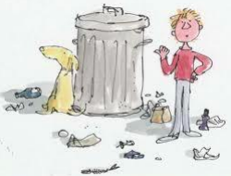

Down behind the dustbin
By Michael Rosen

Down behind the dustbin
I met a dog called Ted.
'Leave me alone,' he says,
'I'm just going to bed.'
Down behind the dustbin
I met a dog called Roger.
'Do you own this bin?' I said.
'No. I'm only a lodger.'
Down behind the dustbin
I met a dog called Sue.
'What are you doing here?' I said.
'I've got nothing else to do.'

