I can scale up a recipe
How much of each ingredients do I need to make 24 cakes ?
Rice krispie and peanut butter cakes
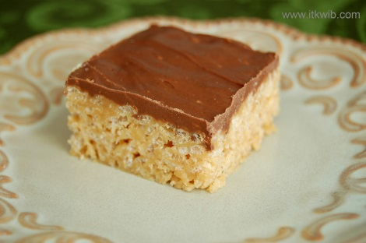
Recipe makes 12 cakes.
1 tablespoon of margarine
3 tablespoons of peanut butter
1000g of marshmallows
2000g of rice krispies
500g of chocolate
I can scale up a recipe
How much of each ingredients do I need to make 40 biscuits?
Stained glass window biscuits
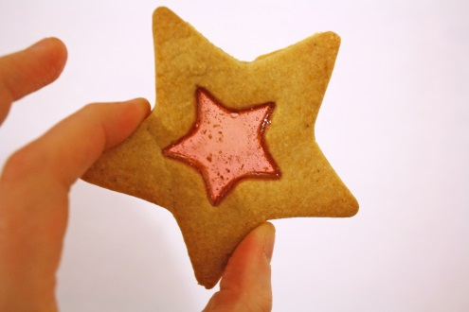
Recipe makes 20 biscuits
250g of boiled sweets
100g of butter
50g of caster sugar
200g of plain flour
1 tablespoon of milk

CHALLENGE: What if I wanted to make 48 rice krispie cakes?

