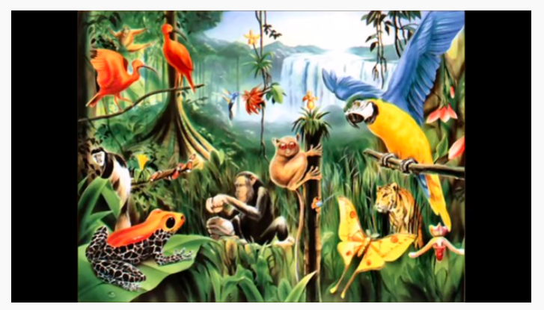

I can see the brightly coloured, feathered parrot with the beautiful, blue wings.
I can see …

I can hear …

I can smell …

I can feel …

