How much sugar is in our food?

Sometimes it can be difficult to really see how much of each food group is in what we eat and as a result, how healthy it could be for us. If we look on the back of food packaging, we normally see the ingredients list and its nutritional information. This is where we can find how much sugar is in our food.
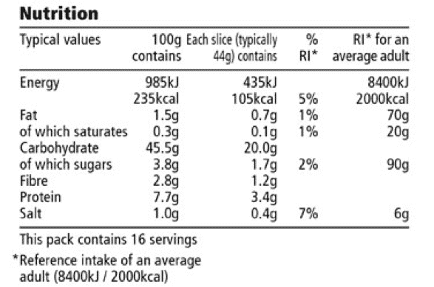

Using the conversion below, can you use your maths skills to work out how many whole cubes of sugar are in our favourite food and drinks. There are a few empty rows for you to add your own foods too!
Children are recommended by NHS to have no more than the equivalent of 6 sugar cubes a day
1 sugar cube = 4g sugar

Example: A Kit Kat bar has 20g of sugar, so it contains 5 sugar cubes. (5x4g)

Food and Grams of Sugar | Sugar Cubes
A donut (18g)
A cup of orange juice (20g)
A tube of Smarties (25g)
A carrot (3g)
A can of Coke (36g)
A cup of water (0g)

