Friday 22nd January 2021

It’s Friday and the end to our third week of home learning!

I hope you have had fun and haven’t got blown away in the high winds we have been having!

See you at 11.30am this morning for our weekly zoom.

Mrs Hoddy

Subject Resources List

Handwriting:
- Whiteboard
- Whiteboard pen
OR
- Pencil
- Exercise Book/Paper

Phonics:
- Whiteboard
- Whiteboard pen
- Pencil
- Exercise book
- GROUP 1: paper and a bowl
- GROUP 2: paper

Maths:
- Pencils
- Paper
- Exercise book
- Number line (you could use a ruler)
- Tens frame
- 20 items (10 one item and 10 another)

Literacy:
- Pencil
- Exercise book
- Phonics mat

Geography:
- Jug with millilitres
- 7-day grid
- Pencil

Art and Literacy:
- A grid as shown in the task box
- Pencil
- Colouring pencils
- Phonics sound mat

Handwriting (10 minutes) | Can you practice the letter u?  Try writing:  u  emu  running  the running emu  This video might help:  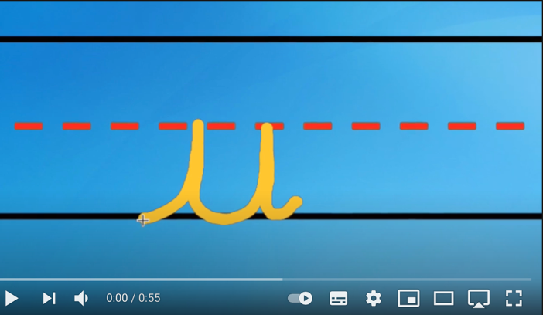  https://www.youtube.com/watch?v=2TXb8uoSXsU
Phonics Group 1 (20-30 minutes) | Today we are learning the 'er' digraph. Watch the teaching video below:  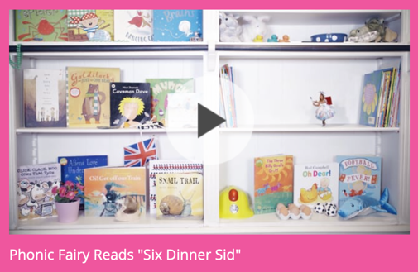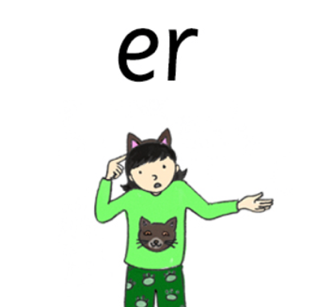  Login details:  https://ttsstorytimephonics.co.uk/  Username: Sporle Primary  Password: XA$Ii@VB!QM8NqSh8iyeQHMg  Task:  Write these words on a small piece of paper, fold them up and put them in a bowl. Pick one out, sound it out and blend the sounds into a word. Once you know what the word is, say a sentence with the word in it.  dinner, letter, ladder, better, summer, butter, cracker
Phonics Group 2 (20-30 minutes) | Today we are learning the 'ew’ digraph. Watch the Phonic Fairies video below:  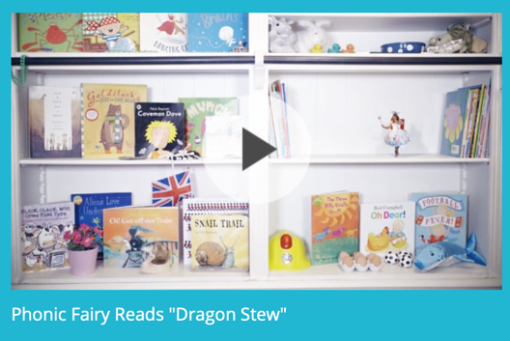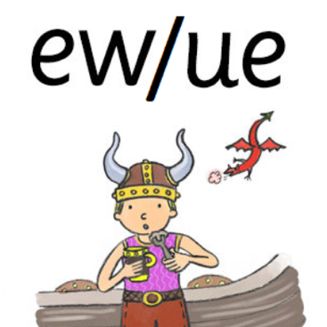  Login details:  https://ttsstorytimephonics.co.uk/  Username: Sporle Primary  Password: XA$Ii@VB!QM8NqSh8iyeQHMg  Task:  Read the ‘ew’ and ‘oo’ (same sound) words then make sentences from them until you’ve used all the words. Read the sentences outload using punctuation.  few, stew, chew, knew, shampoo, poo, roof
Maths (20 minutes) | Today in maths we are consolidating what we have learnt over the past few weeks.  Task: have a go at answering these questions  1.  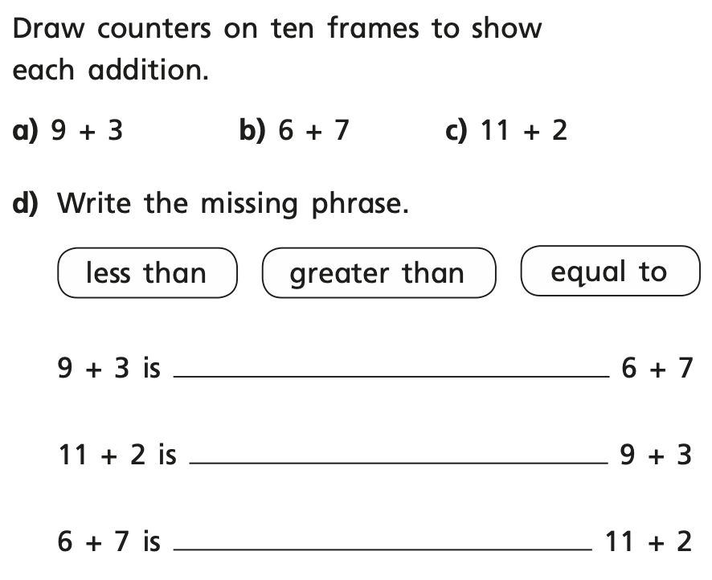  2.  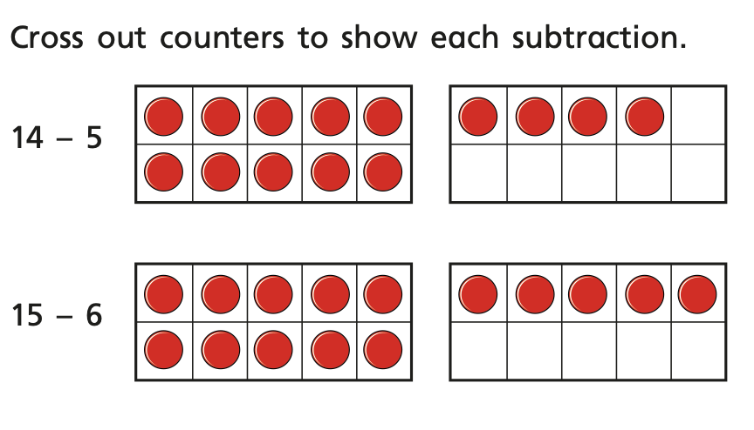  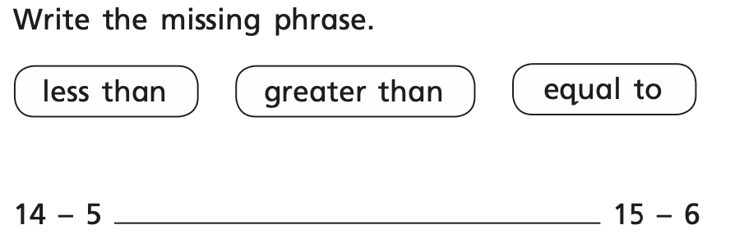  3.  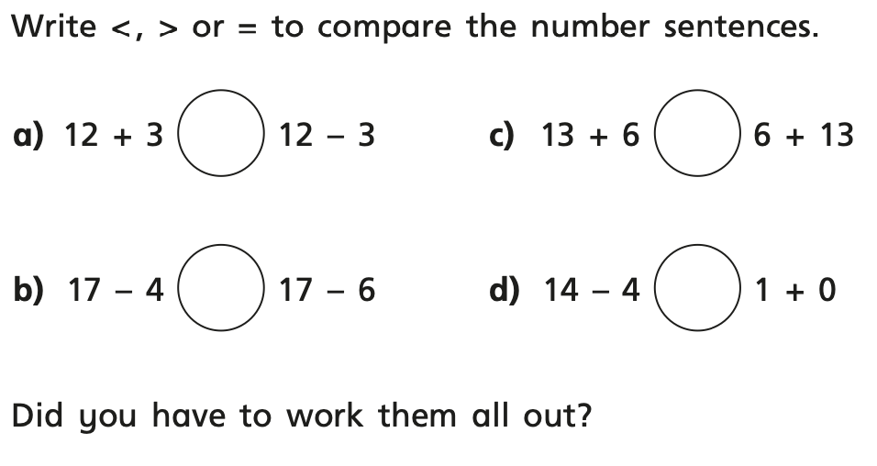  Extension question:  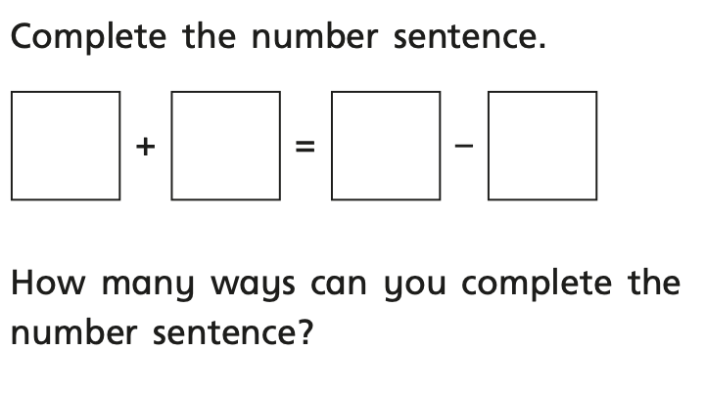
Geography (5 minutes) | Measuring rainfall: measure todays rainfall in millilitres on your 7 day grid at the end of the day.  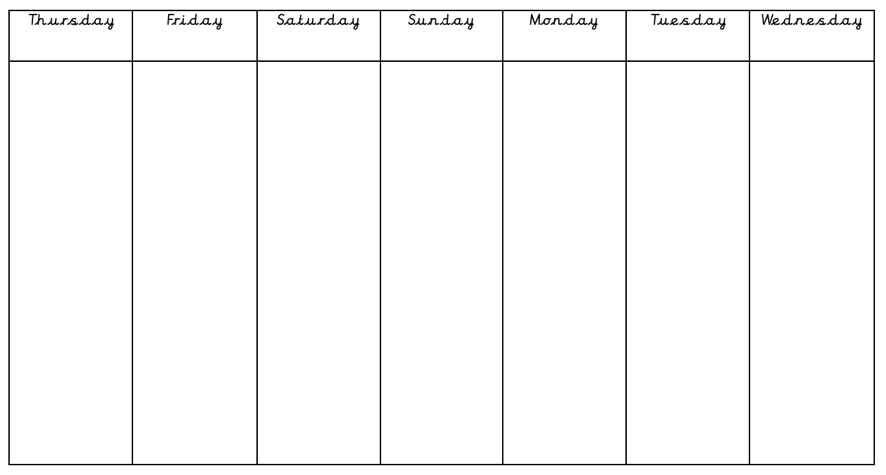
Art and Literacy (20 minutes): | Giant Project:  Next week we will be making a giant from craft items and materials that are in your house! Using the document below as a template (or you can print it out) begin by drawing how you would like your giant to look, add labels and equipment you will need to use to make it next week. Can you add joints so you are able to make your giant move? For example, you could use split-pins or rubber bands as a joint.  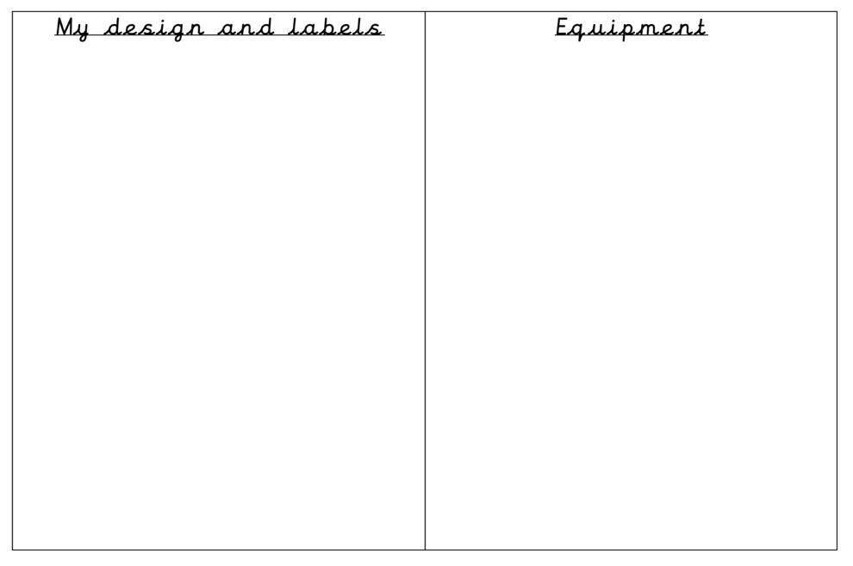
Story time/  Dough Disco | Watch the dough disco video below:    https://www.youtube.com/watch?v=N4Y_dw023G8

