Continuing with our focus on writing instructions, today we would like you to have a go at completing a craft activity but as you do it, we would like you to make notes of the steps you use because tomorrow you will be writing the instructions! We have put some ideas below of things you might like to make but if you have a different idea that you think other children might like to make – please do your idea instead. We look forward to seeing all your creations.

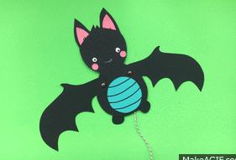
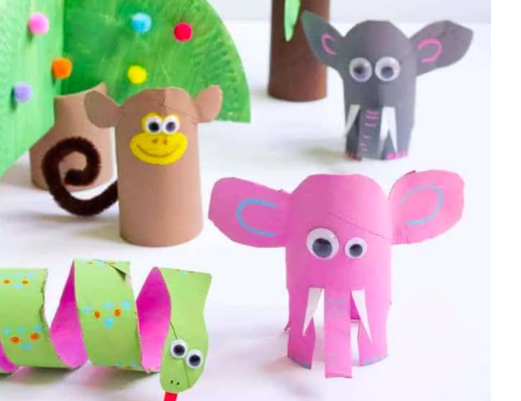
3D jungle animals A bat with moving wings

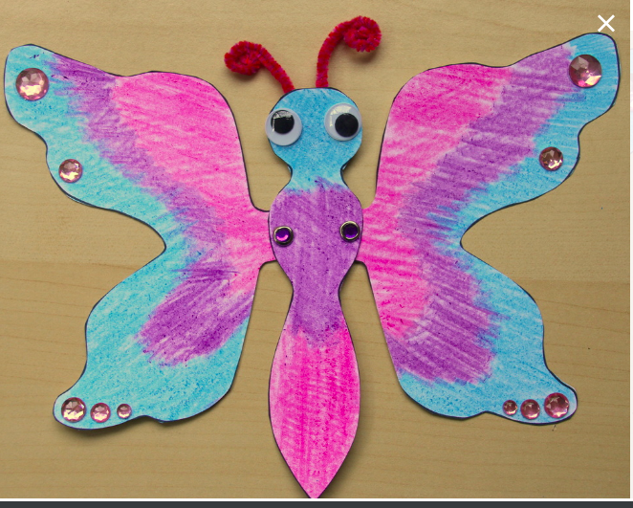

A butterfly with moving wings (split pins)

