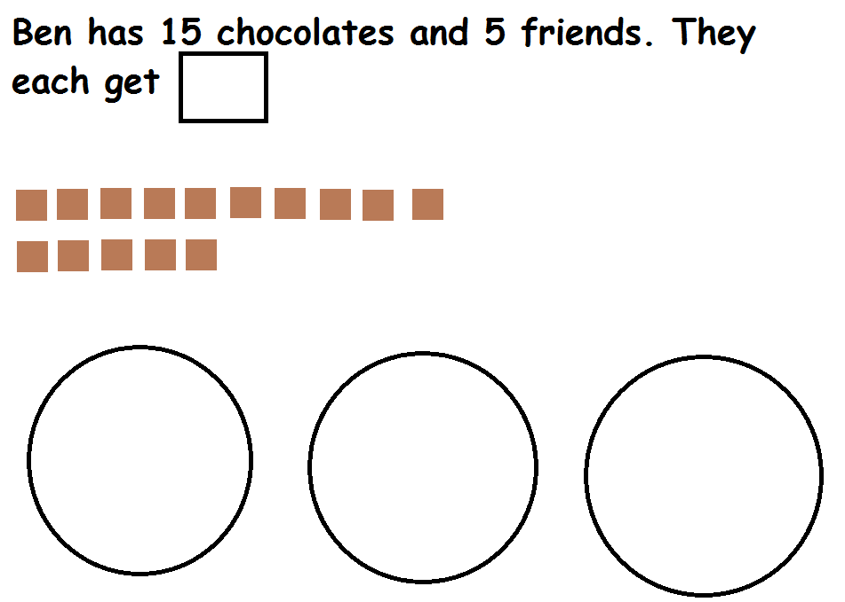
Basic skills – Division
3
15 ÷ 3 =

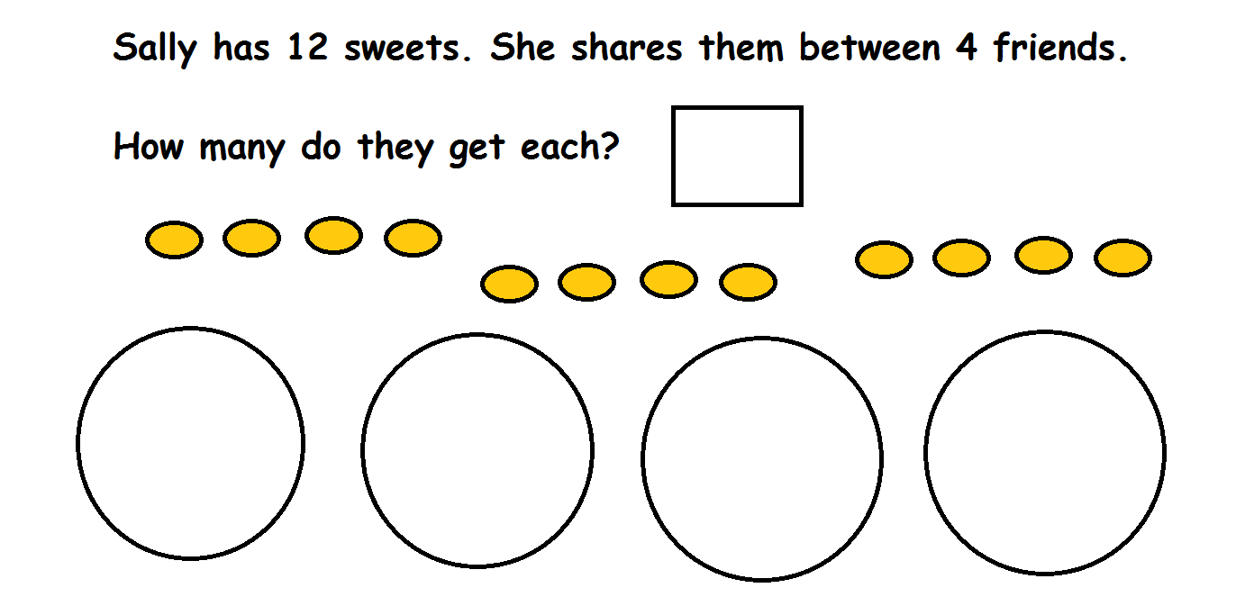
12 ÷ 4 =

Try these. You can draw pictures in your maths book to help you.
- 20 ÷ 5 =
- 16 ÷ 4 =
- 9 ÷ 3 =
- 24 ÷ 8 =

