PE: Personal Challenge 1
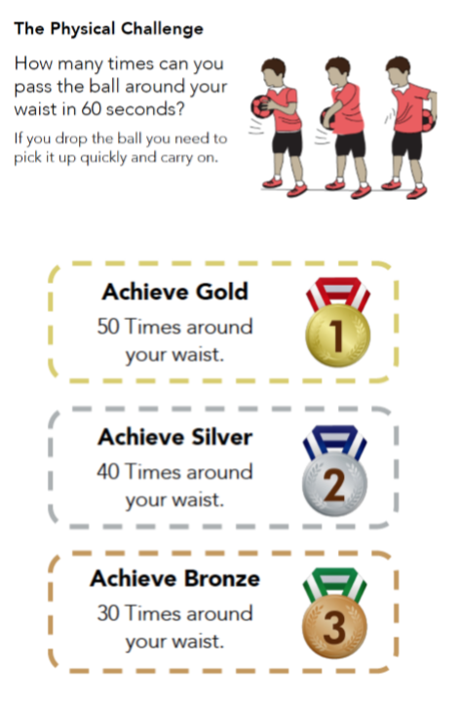
Around the world challenge

Keep practising, and upload you best score to class dojo.

