English – Thursday 7.1.2021

Comprehension

Today our focus will be on reading texts and answering questions relating to them. Please choose one that is appropriate to the reading level of your child.

Reading

Draw a timeline of events in a story you have read. What will you draw for the beginning of the story? What happens next? What will your time line look like? We look forward to seeing all the different ways you have chosen to draw your timeline.

Handwriting

Please copy out the poem Planet Blatt using the cursive handwriting style.

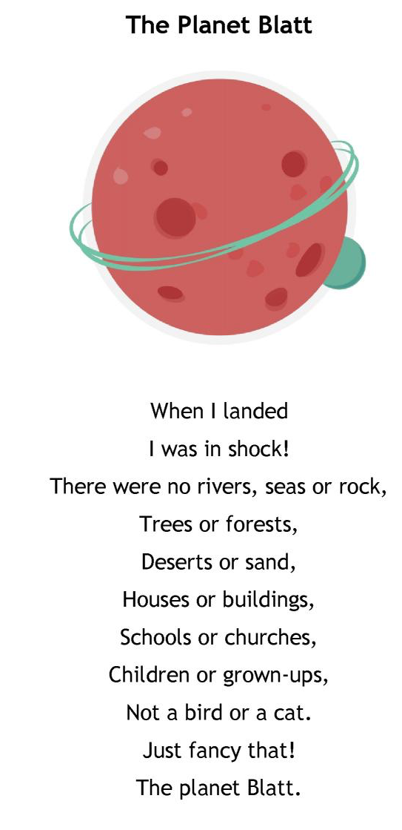

The Planet Blatt

When I landed …

Remember – you do not join a capital letter to the next letter.

