
Nar Valley Federation

5-week Animal Project

For the next 5 weeks we are going to be working on an animal project. Mrs Neary thought that this would be a lovely way for the whole of the Federation to complete the last few weeks of this academic year.
Each week there will be a different element that looks at different habitats or types of animals. These will build up week on week to create your overall project, which we would like you to bring into school when we return, so that we can share and celebrate the learning that you have been doing.
- Week 1 – Nocturnal Animals
- Week 2 – Peru – South American Animals and Habitats
- Week 3 – Sea Creatures
- Week 4 – African Animals – The Savannah
- Week 5 – Endangered Animals

We will be covering all different areas of the curriculum during the weeks and providing links, videos and other useful resources and ideas.

Nar Valley Federation – Animal Project
Endangered Animals

Vocabulary:
prey predator habitat behaviour nocturnal night dusk twilight forage hunt/hunter creature species senses physical traits adaptation manoeuvrability
Book Ideas:

EYFS / KS1

Elmer
We’re going on a bear hunt
Bears don’t eat egg sandwiches
Very important animals
You can’t take an elephant on the bus!

KS2

The Akimbo Adventures
The Hunter
The Butterfly Lion
The White Giraffe

EYFS / Y1

Monday: YR/ Y1 - Watch and learn about animals such as tigers and why there are not very many of them left in the world.

https://www.youtube.com/watch?v=7k8CcAU2Lt0

Task 1

Tuesday: Using 6 sheets of A4 paper or card make 6 triangles like this
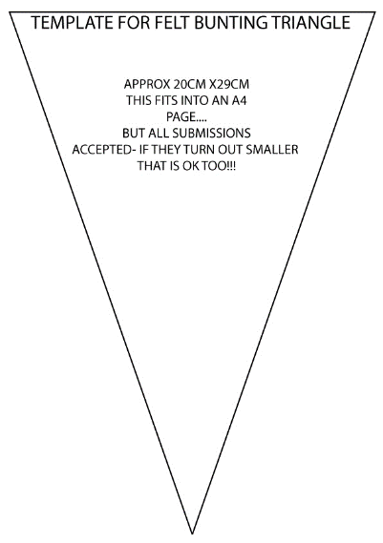

Once you have cut your triangles out fold over a 1cm strip.
You are going to draw an endangered animal on each one.
- An elephant
- A tiger
- A rhinoceros
- A panda
- A gorilla
- A turtle

Reception Children: Turn over your triangle and write the name of your animal on the back.

Year 1 Children : Now you are going to turn your triangle over, and you can write one fact about each of these animals.

Ask your parents to help you find a fact about each animal – you can use websites like this one.

https://www.dkfindout.com/uk/more-find-out/special-events/endangered-animals/

https://animalfactguide.com/animal-facts/

After that, place your triangle with the flap over some coloured wool or string and make your bunting.

Wednesday: Task 2

Watch the video link and see if you can learn the song.

‘I had a little Turtle’

https://www.youtube.com/watch?v=rmZySo0OHIQ

Thursday: Task 3

Story - How the Tiger got his stripes
Have a go at creating a storyboard to show the events in the story!

https://www.youtube.com/watch?v=rf7ascNGbcM

Friday: Enjoy the last day before the Summer Holidays! You have all worked so incredibly hard during your time away from school. Remember to collect your goodie bag and bits and pieces from school today (Friday 17th July 2020)!

Science:  EYFS / KS1  Watch this video and if you can have a go at some of the experiments. There are lots to choose from.  https://www.youtube.com/watch?v=087hssnar-0 | Art  EYFS /KS1  Look at these fun ideas for creating your own piece of artwork  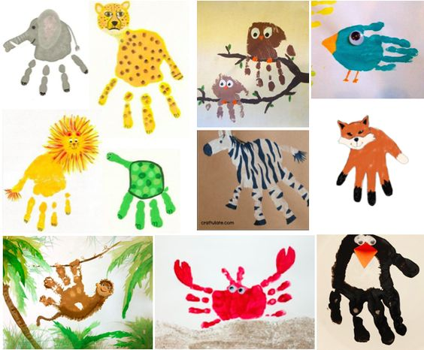  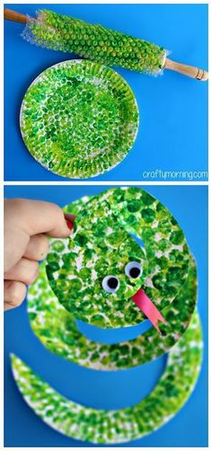  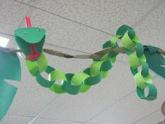  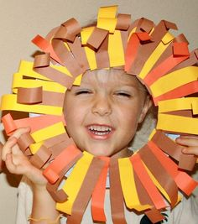  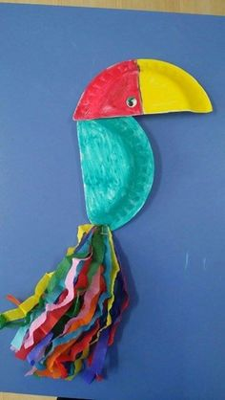  Simple but effective sculptures!  

