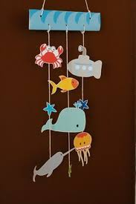
- Draw or make your OWN sea creatures to hang on your mobile.
- Print and cut out images of creatures form online.
- Use a piece of card, a coat hanger, a paper plate, a small hoop, half a plastic bottle etc. – to hang you items from



