
Nar Valley Federation

5-week Animal Project

For the next 5 weeks we are going to be working on an animal project. Mrs Neary thought that this would be a lovely way for the whole of the Federation to complete the last few weeks of this academic year.
Each week there will be a different element that looks at different habitats or types of animals. These will build up week on week to create your overall project, which we would like you to bring into school when we return, so that we can share and celebrate the learning that you have been doing.
- Week 1 – Nocturnal Animals
- Week 2 – Peru – South American Animals and Habitats
- Week 3 – Sea Creatures
- Week 4 – African Animals – The Savannah
- Week 5 – Endangered Animals

We will be covering all different areas of the curriculum during the weeks and providing links, videos and other useful resources and ideas.

Nar Valley Federation – Animal Project
Sea Creatures
Vocabulary:
Habitat, equator, tropic of cancer, tropic of Capricorn, longitude, latitude, climate, ocean, sea, solution, dissolve, evaporation, adaptation,
English Ideas:

Listen to the myth: why is the sea salty
https://www.youtube.com/watch?v=vnJTzICdzQs

EYFS/Year 1
Create a picture to show how the sea became salty, and add a caption to your picture to explain what is happening.

Years 2/3
Create a story board of the story to show the key events. Remember to add a caption to each picture to describe what is happening.

Years 4/5/6
Write your own myth to explain why the sea is salty. (It will need to explain how salt got into the sea).

Who is David Attenborough?
EYFS/Year 1
Use ‘kiddle’ to find a picture of David Attenborough. Can you write some words to describe him?

Years 2/3
Find out who David Attenborough is and what he is famous for. (You can use the internet to research him, watch video clips). Write a fact file about David Attenborough based upon your research.
Years 4/5/6
Who is David Attenborough? Research his main achievements and write a biography about him.

Be David Attenborough

Watch some clips from blue planet on iplayer/you tube. (Some suggestions below) Hint: David Attenborough is narrating.
The fish that uses tools
https://www.youtube.com/watch?v=LnOYpuKV4H4
Orca hunting herring
https://www.youtube.com/watch?v=SabxJ0nqKlE
Clownfish teamwork
https://www.youtube.com/watch?v=WWlDa7CA_5w
Portuguese man o war
https://www.youtube.com/watch?v=gr1ps0ooDhU
Or select your own (there are loads to choose from)
https://www.youtube.com/results?search_query=blue+planet+2

Notice how each clip tells a story of that particular animal….
Your mission is to choose a sea creature (fish, mammal, mollusc…) and to create a narrative about that sea creature in the style of blue planet. You will need to find out facts about your sea creature first (appearance, size, diet, how it moves, how it is adapted to live in the sea, behaviour). You will then need to decide what you want to tell the audience about your animal.
EYFS/Year 1:
This could be you describing your sea creature (what it looks like, what it eats)
Year 2/3
This could be you describing an aspect of the behaviour of your sea creature (e.g. hunting for food)
Year 4/5/6
This could be you creating a real-life story about your sea creature based upon it’s behaviour, where the audience really connect with your animal (like the fish using tools, or the clownfish teamwork).
You can write, perform your narrative to your family, record your narrative and upload it to dojo…the choice is yours.
You may wish to use a video clip that you have found to provide your own narration, or produce some art work to go with your ‘story.’

Science ideas:  EYFS/KS1  What are fish? Find out by clicking on the link below.  https://www.bbc.co.uk/bitesize/topics/z6882hv/articles/zxgq2hv  What is an ocean habitat? Find out by clicking on the link below.  https://www.bbc.co.uk/bitesize/topics/zx882hv/articles/zsfkd2p  KS2  What is dissolving?  https://www.bbc.co.uk/bitesize/topics/zjty4wx/articles/zpbdpbk  What is separation?  https://www.bbc.co.uk/bitesize/topics/zjty4wx/articles/zrgj2sg  Separating mixtures of materials  https://www.bbc.co.uk/bitesize/clips/zb9c87h#:~:text=Salt%20can%20be%20separated%20from,This%20process%20is%20called%20distillation.  Learn about the water cycle.  https://www.bbc.co.uk/bitesize/clips/z8qtfg8  Explore how the density of salt water is different by having a go at this experiment  https://sciencekiddo.com/salt-water-experiment-ocean-science/  All year groups:  Salt water experiment.  Mix a teaspoon of salt into 50ml (approx) of water and stir. What do you notice happens to the salt?  Pour the salt water mixture into a shallow dish (e.g. a shallow bowl/plate/saucer) and leave on a sunny windowsill. What do you notice?  After a few days, record what you noticed. Can you explain what happened to the salt and water using scientific vocabulary? | Geography ideas:  Learn about how the oceans effect weather by watching the videos by David Attenborough  https://www.bbc.co.uk/bitesize/articles/zw7vtrd?xtor=CS8-1000-[Discovery_Cards]-[Multi_Site]-[SL08]-[PS_BITESIZE~N~~A_TravelTheWorldWithDavidAttenborough]  Find out about the oceans of the world  https://www.bbc.co.uk/bitesize/topics/z849q6f/articles/zmqwscw  Can you locate and name the major oceans of the world? (You could print off the map of the world below)  Learn about longitude and latitude  https://www.bbc.co.uk/bitesize/topics/zvsfr82/articles/zd4rmfr#  Can you label the equator, tropic of cancer, tropic of Capricorn to your map of the world?
Art ideas:

Create a shoe box/ 3D model of the ocean habitat for your sea creature
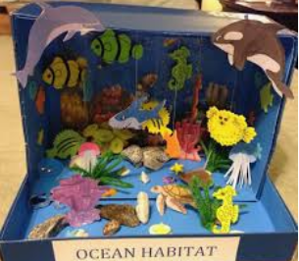
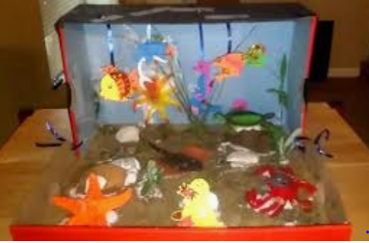

Create a 3D model of your chosen sea creature out of salt dough, clay or fabric

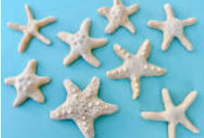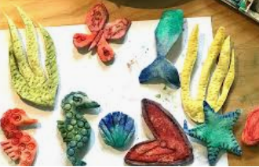

Create a picture / sculpture of your chosen animal. Use a medium of your choice
- Paint
- Crayon
- Sketch
- Pastels
- Collage
Textiles

Story board template



