
Nar Valley Federation

5 Week Animal Project

For the next 5 weeks we are going to be working on an animal project. Mrs Neary thought that this would be a lovely way for the whole of the Federation to complete the last few weeks of this academic year.
Each week there will be a different element that looks at different habitats or types of animals. These will build up week on week to create your overall project, which we would like you to bring into school when we return, so that we can share and celebrate the learning that you have been doing.
- Week 1 – Nocturnal Animals
- Week 2 – Peru – South American Animals and Habitats
- Week 3 – Sea Creatures
- Week 4 – African Animals – The Savannah
- Week 5 – Endangered Animals

We will be covering all different areas of the curriculum during the weeks and providing links, videos and other useful resources and ideas.

Nar Valley Federation – Animal Project
Peru-South American animals and habitats

Vocabulary:
bear, spectacled, Andean, habitat, carnivore, herbivore, omnivore, mammal, amphibian, reptile, endangered, extinction
EYFS / Y1: Start by listening to the beginning of the story, ‘A Bear Called Paddington’- https://www.youtube.com/watch?v=TKdZ4u6EKiM

Paddington Bear is a friendly bear from deepest darkest Peru. Think about Paddington and how he was described.
What do we know about him?

Task 1-What does he look like? Use the step by step drawing guide below to draw Paddington -

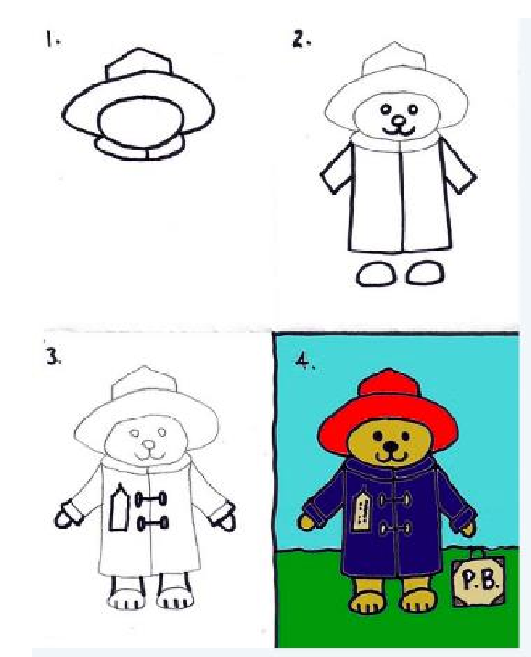
YR- Once you have drawn Paddington write some words to describe what he looks like around him. Can you put some of the words into a sentence?

Y1-
- Write some words around Paddington to describe what he looks like
- Choose a different colour to write in and write some words to describe what he is like as a character (polite, friendly…)
- Choose a different colour again to write what is special about him (his Aunt Lucy taught him, he likes marmalade, he ate a whole jar on the way to England)

Task 2- Paddington is feeling homesick and is missing Peru. Can you find out what Paddington might eat in Peru other than marmalade!? Use the search engine ‘Kiddle’ or look in some books to find out what spectacled bears eat. This website might help- https://www.nationalgeographic.com/animals/mammals/s/spectacled-bear/ Write some sentences about what you find out.
Don’t forget your capital letters, finger spaces and full stops.

Task 3- Can you create him a menu? Write his menu in a list. Add some interesting adjectives to make the menu really mouth-watering! I wonder what he might choose?

Task 4- Write a postcard to Aunt Lucy using some of the ideas below.

Year 2 /3
1-Start by listening to the beginning of the story, ‘A Bear Called Paddington’. You could break this up into different parts to spread it out-
Chapter 1-https://www.youtube.com/watch?v=TKdZ4u6EKiM
Chapter 2- https://www.youtube.com/watch?v=PjAuydxabc4
Chapter 3- https://www.youtube.com/watch?v=elto5u5H_kI
Chapter 4- https://www.youtube.com/watch?v=46YFinIT98o

2-Imagine you are Paddington and you want to send a postcard to Aunt Lucy telling her all about life in London.
If you aren’t sure what the London Underground is or what it looks like, this is a good webpage to use:
https://kids.kiddle.co/London_Underground

You need to tell Aunt Lucy that you have arrived safely, where you are staying and what London is like.
Plan your postcard using the following prompts-
*How did you meet the Browns?
*Who are the Browns? (their names and a bit about them)
*What happened when you had your first bath?
*What food have you eaten?
*What was your trip like on the underground?
*What happened to you at Barkridges?

*Don’t forget to be polite and ask how Aunt Lucy is or a ‘wish you were here’, for example.

Think of some ways to start your sentences so that it sounds like Paddington is talking to Aunt Lucy e.g. “You’ll never believed what happened…
As you write your postcard, keep reading it aloud and looking for any mistakes or parts you could improve.
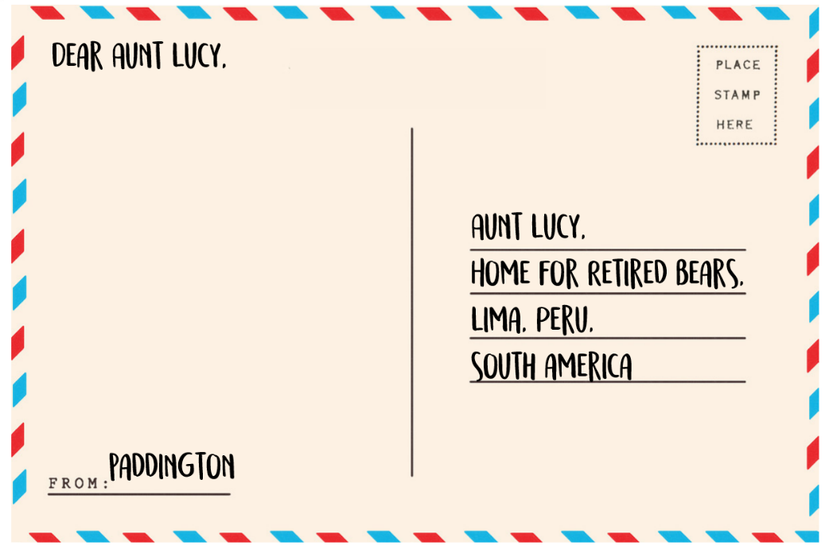

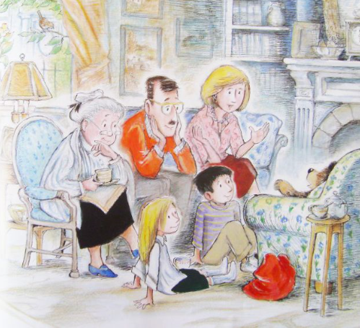
3- Think of some ways you could describe the Browns. Write them all down as you think of them. Group the adjectives together (kind, welcoming, smiling).
Adjectives are often used to tell a reader more about something, adding some description or detail.


4-This is an escalator, it is a bit like moving stairs which go up and down in some underground stations like Paddington Station and some big shops like Primark in Kings Lynn.

List some adjectives to describe it.

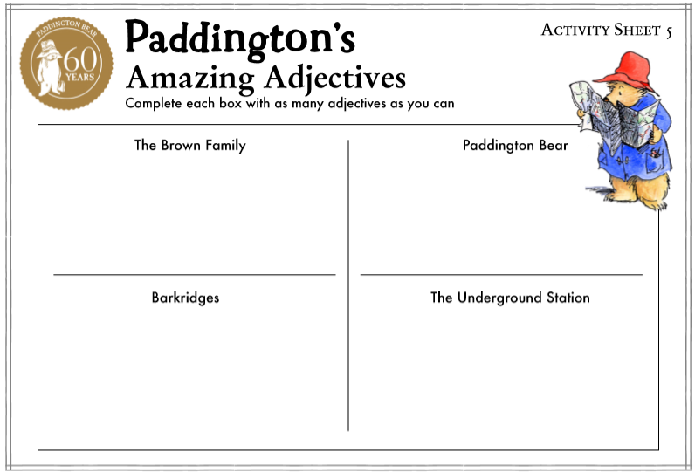
5- Collect adjectives for each of the people and places shown in the boxes opposite.

Go back to your postcard and add at least one adjective to your writing to help Aunt Lucy imagine the scene more clearly (a heavy suitcase, a blue duffle coat, a smelly bacon sandwich, etc.)

www.teachwire.net
Years 4/5/6

1-Start by listening to the beginning of the story, ‘A Bear Called Paddington’. You could break this up into different parts to spread it out-
Or enjoy reading it yourself! It is a free download on Kindle. https://www.amazon.co.uk/Bear-Called-Paddington-Book-ebook/dp/B006UN3FTY

Chapter 1-https://www.youtube.com/watch?v=TKdZ4u6EKiM
Chapter 2- https://www.youtube.com/watch?v=PjAuydxabc4
Chapter 3- https://www.youtube.com/watch?v=elto5u5H_kI
Chapter 4- https://www.youtube.com/watch?v=46YFinIT98o
Chapter 5-https://www.twine.fm/TirzaSchaefer/cxezm0/a-bear-called-paddington-chapter-5
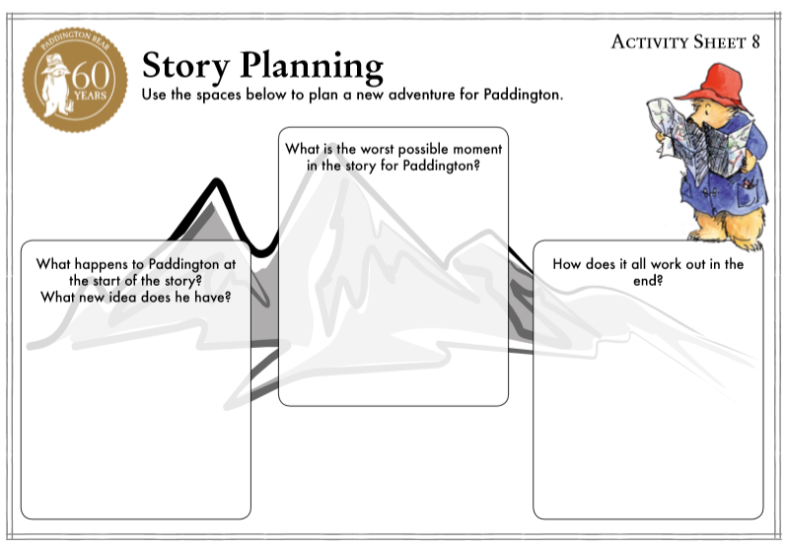

2-Think about the story so far. What have been Paddington’s best and worst moments so far?

Use the format of the 3 boxes opposite to complete the story plan.

3- Now use the boxes to think of ideas for creating your own story.

Use the sheet on the next page to help you with your planning.

www.teachwire.net

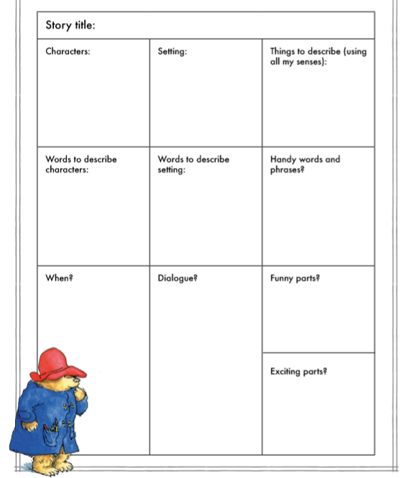
4- Use your planning to write your new story. Don’t forget to keep checking it and reading it aloud, perhaps to someone else, looking for ways to make additions or improvements.
Try and include-
*Prepositions
*Adverbial phrases
*Fronted adverbials
*Similes
*Relative Clauses

You can find out about these in your CPG SPAG books.

Don’t forget to share your story with us!
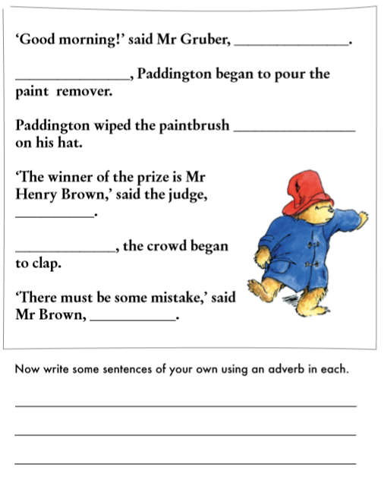
5- Adverbs:
Adverbs provide more information about verbs.

Practise adding adverbs to the sentences opposite.

Is there anywhere in your story where adding an adverb would improve your story?

6- Write a newspaper article for the ‘Portobello Post’ telling the story of Mr Brown’s (and Paddington’s) win in the painting competition.
Try and include-
*Relative clauses (adding extra information) you could use brackets
* Commas
* A dash Y5/6
* Quotes from another character related to the event

You could include an interview with the characters and even a picture of the winning masterpiece!

Science/ Geography:  Reception/ Year 1- Think about what you would pack in your suitcase if you were going to visit the Spectacled Bears (Andean Bear) in Peru? You could draw or write about these things.  Find Peru on a map, an atlas or a globe. Can you find Lima where Aunt Lucy lives with the retired bears?  Y1 and above- Use books and the internet to research the Spectacled Bear (Andean Bear). You could use the headings below as a guide to create a fact file about the bear.  Habitat- A description or a picture to show where Spectacled Bears live. Try and find Peru and Lima where Aunt Lucy in Paddington Bear lives.  Picture/ photo- What does the bear look like?  Interesting fact- Draw or write something interesting about this animal.  Eats- What do Spectacled Bears eat? Are they carnivores, herbivores or omnivores?  Animal: Are they a bird, mammal, fish, reptile or amphibian?  Years 3/4/5/6-How does it adapt to its environment?  Resources and links you could use-  https://www.chesterzoo.org/app/uploads/sites/5/2019/04/Animal-Fact-File-Andean-Bear.pdf  http://www.bearconservation.org.uk/andean-spectacled-bear/  https://www.nationalgeographic.com/animals/mammals/s/spectacled-bear/  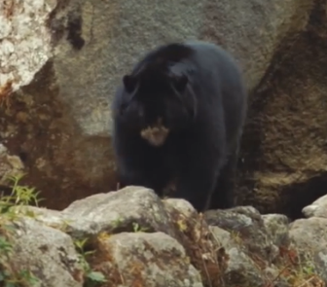  Video-  A National Geographic Video- CTRL and Click on the picture  Books-  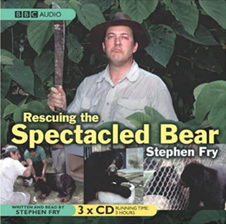  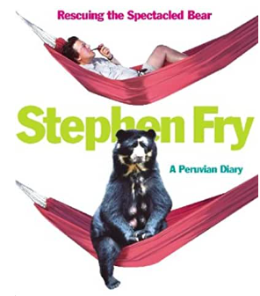  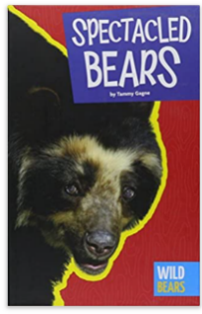  Endangered Bears-  *Find out about the Spectacled Bear (Andean Bear), Panda and Polar Bear, where they can be found in the world? Use an atlas, a globe or the world map attached to the resources.  There is a fun song to remind you of the continents here too-  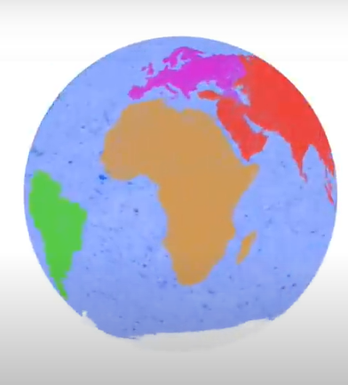  CTRL and click on the picture  Y2-6- Find out why the bears are endangered. What is being done to stop them from becoming extinct? You can choose how to present your findings. You might-  *Do a PowerPoint  * Present your findings to your family or send us a video via Class Dojo  * Make a colourful poster  You decide!  Resources-  https://www.chesterzoo.org/news/update-from-bolivia-and-our-andean-bear-project/  https://www.chesterzoo.org/news/protecting-spectacled-bears-in-peru/  https://www.worldwildlife.org/species/polar-bear  https://arcticwwf.org/species/polar-bear/threats/  http://www.bearconservation.org.uk/polar-bear/  https://www.worldwildlife.org/species/giant-panda  http://www.chinatourmap.com/panda/conservation.html  We will be learning more about more endangered animals in Week 5.  Take a photo for your project – send the photo in and we can make a gallery on the website. | Art/ DT  YR and Y1- Make a mask of a bear-  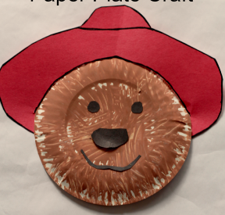  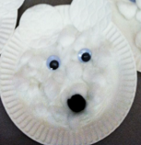  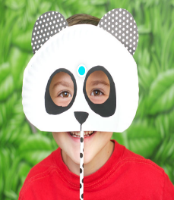  You could make a mask like one of the ideas above or you could design and make your own.  Y1-6 *Create a 3D model of a Spectacled bear using playdough/clay/ salt dough  *Wanting a challenge? Try making a DIY geometric bear. If you don’t want to include sewing you could just do some drawing using a straight edge and a pen.  https://www.youtube.com/watch?v=9l61hKhjfqc  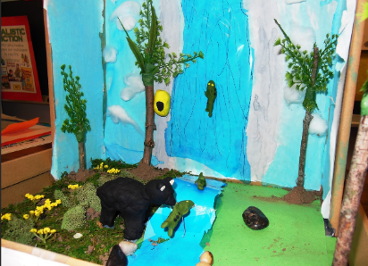  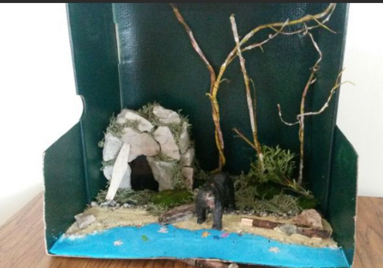  Any year group- Create a habitat in a shoebox or make a diorama (3D model) for an Andean bear.



