Tuesday 16th June 2020
Year 1
English | Listen and enjoy The Lighthouse Keeper’s Lunch here:  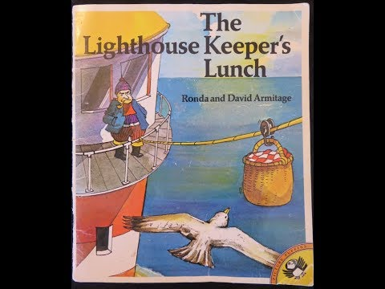  For an extra challenge today, if you have any at home have a taste of mustard! What did you think of it?  Year 1: Write a 5 sentence story using the following sentence starters about The Lighthouse Keeper’s Lunch  Once  One day  Unfortunately  Luckily  In the end  Then design a lunch you think that the seagulls wouldn’t like! The foods you choose don’t have to be edible! Make each food taste truly disgusting to put the seagulls off! Draw a picture of each of your food items on a lovely picnic table like this and label each type of food. 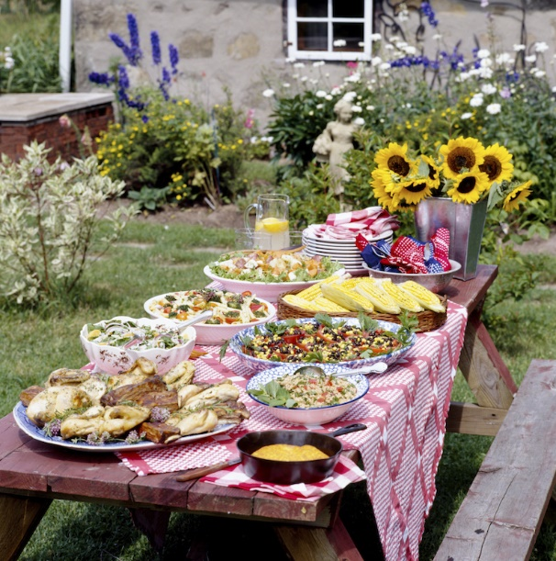  And tell me why you chose those foods!
Maths | A Picnic Lesson!  (Adults: if you have counters/coins/cubes, these might be useful for this lesson)  Sharing  You have a basket of 24 apples. You have 3 friends with you (so that’s 4 people altogether). How many apples would you each get?  There are 2 full quiches which are each cut into 6 pieces. How many pieces would you each get of the quiche? Is it possible for you each to have the same number of slices?  Sorting  There are 12 apples. They can be red or green. Show me the ways the apples could be sorted.  e.g. 5 red and 7 green.  Patterns  Have a go at sorting the apples into repeating patterns. There are 12 apples, 6 of them are red and 6 are green. See if you can create 2 different patterns!  Measuring  Mr Grinling’s basket is only able to carry 1kg of food. Weigh some foods you have in your kitchen to see what foods he is able to carry in there without it toppling into the sea!
Topic | Today’s task is to have a go at creating your own string system to recreate the lighthouse and the house on the mainland! You could even design your own story where someone might need something being given to them and have a go at creating that too!  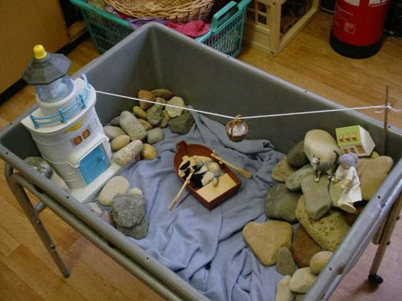  If you don’t have the equipment to do this, you could have a go at drawing the line system on Paint on a computer.  I’ve attached a set of instructions to create a pulley system which is linked to the system used in the book.

