Tuesday 16th June 2020
Reception
English | Listen and enjoy The Lighthouse Keeper’s Lunch here:  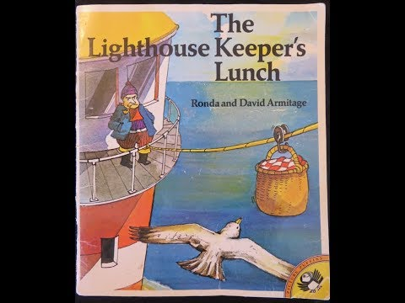  For an extra challenge today, if you have any at home have a taste of mustard! What did you think of it?  Reception: Can you build your own lighthouse? You could even attach some string to your lighthouse to represent the lunch arriving! Here is an idea:  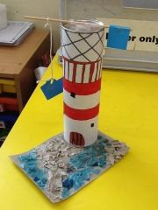  Then design a lunch you think that the seagulls wouldn’t like! The foods you choose don’t have to be edible! Make each food taste truly disgusting to put the seagulls off! Draw a picture of each of your food items on a lovely picnic table like this and label each type of food.
Maths | Measuring  The Lighthouse Keeper has asked for a delicious smoothie for his lunch today. Could you make him one using things you have at home (water, juice, yoghurt, fruit etc.)? You could measure out th ingredients with a spoon like this:  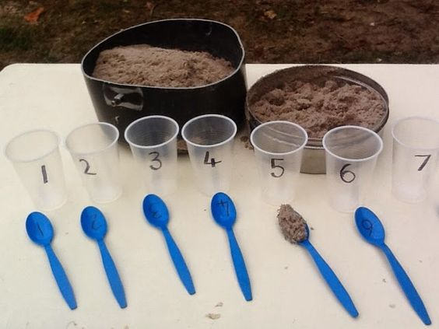  Can you write your recipe down so that other people can make your smoothie?
Topic | Today’s task is to have a go at creating your own string system to recreate the lighthouse and the house on the mainland! You could even design your own story where someone might need something being given to them and have a go at creating that too!  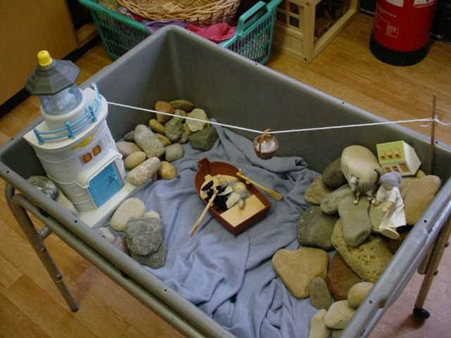  If you don’t have the equipment to do this, you could have a go at drawing the line system on Paint on a computer.  I’ve attached a set of instructions to create a pulley system which is linked to the system used in the book.

