Monday 15th June 2020
Reception
English | Lighthouses  Why are lighthouses important? Who relies on lighthouses? What would happen without them?  Find out a little more about lighthouses in these video:  https://www.youtube.com/watch?v=QbyGznyf7BI  Take a look at some lighthouses around the English coast, how tall they are and what they’re made out of here: https://www.youtube.com/watch?v=rUoqhWbebHQ  We read Hello Lighthouse (you can hear it being read here): https://www.youtube.com/watch?v=hlJ4wRuqsZw) when we were in school and saw some incredible pictures of what lighthouses look like inside:  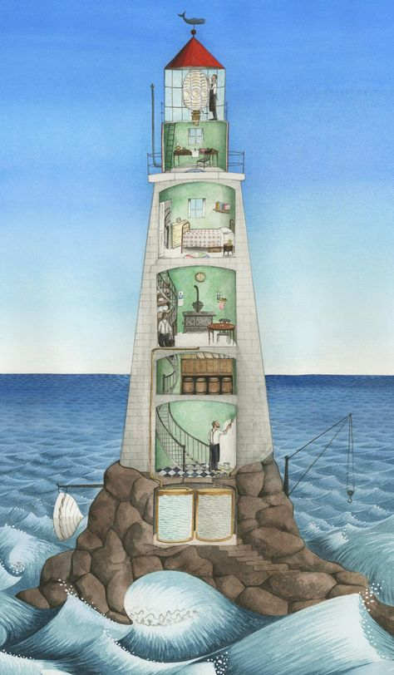  Take a look at this video which shows a Lighthouse Keeper’s day:  https://video.nationalgeographic.com/video/short-film-showcase/0000014c-759f-d234-affd-ffdf65cc0000  This lighthouse is located in a place called Uruguay 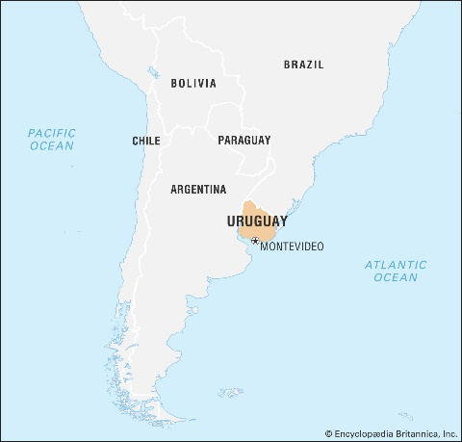  Reception:  Lighthouse keepers have very busy days!  Tell me one thing the lighthouse keeper did in the morning, one thing he did at lunch time and one thing he did at night time. (You can use the picture above to help remind you or make something else up if you can’t remember )
Maths | Money Money, Money!  Can you remember the names/amounts of the different coins? 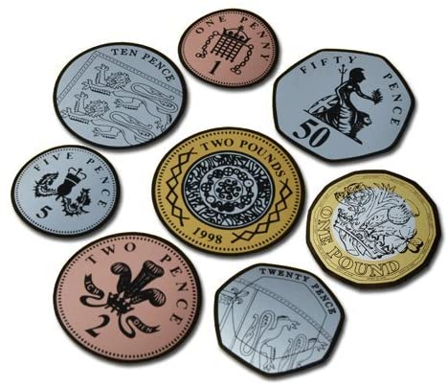  Can you design your own shop and price up items you have around the house? Like this: 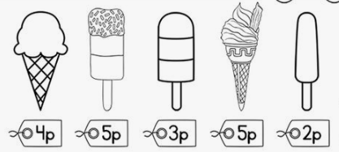  Ask the adults in your house for some coins you can use to practise counting so that you can buy items from your shop!  Could you write some shopping lists for people to use when they come to your shop?
Topic | Light  In the Autumn Term, we learned about light and dark and were able to explore different materials in the Dark Den!  Today, I’d like you to have a hunt around your house for different sources of light (these are things which produce their own light). Make a list of the light sources you find.  The light in the lighthouse is there to keep people safe.  Were there any light sources you found in your house which are there to keep people safe?  Your task is to create your very own light tunnel (cut out circles in pieces of paper/card and stand them in a line so that a torch light can shine through each of the circles – I’ve created this picture to give you an idea).  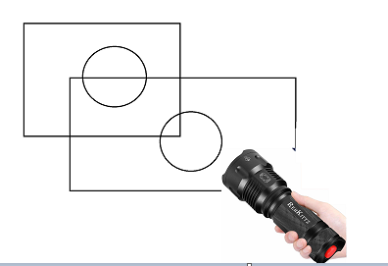  You could even have a go at cutting the circles in different sizes to see if it makes a difference to the beam of light coming from the torch.

