Hedgehog Fact File
- Hedgehogs curl up into a ball for protection.
- Hedgehogs have prickly spines everywhere except their face and tummies.
- If a fox, badger or other predator ap- proaches the hedgehog will roll up onto a tight ball.
- Hedgehogs eat insects, small mice, lizards, frogs, eggs and even snakes!
- Even though they mainly stay on the ground, hedgehogs can swim and also climb trees.
- If it falls from the tree it will roll into a ball and then bounce.
- They will normally live for about 7 years.
- Hedgehogs are nocturnal, this means they are awake at night and sleep during the day.

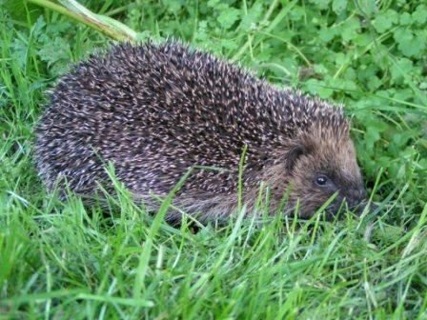

Badger Fact File
- Badger’s are nocturnal, this means that they are awake at night time.
- They are omnivores which means they eat mainly earthworms but also rodents, young rabbits, insects, and plant matter.
- Most badgers are large, nocturnal, burrowing animals, with broad, heavy bodies, long snouts, large, sharp claws, and long, grizzled fur.
- Badgers like to build their setts into sloping ground in woodlands
- Badgers live in family groups the badgers they dig out and live in a maze of underground tun- nels and chambers called a sett.
- Badgers are rarely seen during the day, but forage for food at night.
- Badgers can live for up to 14 years, but are likely to die or be killed before they reach this age.

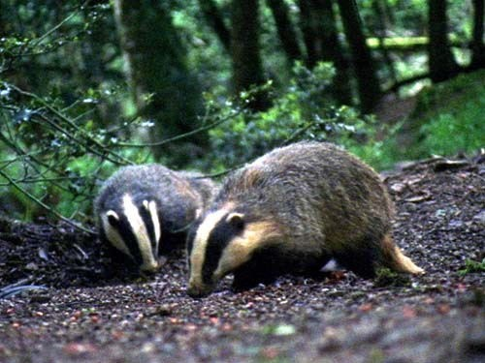

Fox Fact File
- Foxes look a bit like dogs with a pointed muzzle and bushy, white-tipped tail ("brush"). They have a red- dish-brown coat and their lower legs and the backs of their ears are black.
- They eat earthworms, rabbits, rodents, birds, in- sects and fruit.
- Foxes are mostly active at night, their eyes being specially adapted to night-time vision.
- The fox's hearing is also excellent, helping it to lo- cate prey easily.
- A country fox will eat carcasses or kill small mam- mals, especially voles and rabbits; in summer it will eat beetles and fruits in the autumn.
- A town fox visits households that regularly put out food for them and generally scavenge for anything edible.
- Foxes live for 18 months to 2 years in the wild.

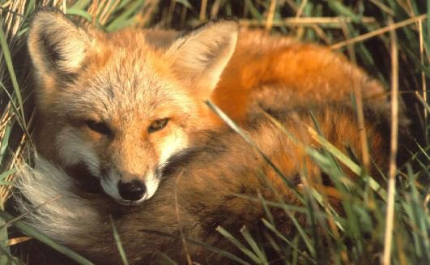

Bat Fact File
- A long time ago, people used to think bats were birds without feathers. But now we know that there is no such thing as a featherless bird. We know that bats are mammals, just like people .
- They are the only mammals that can fly (without an airplane!)
- Vampire bats prey mainly on cows, horses and other large mammals. They make a shallow wound with their razor-sharp teeth then they lick up the
blood. Each bat only drinks about an ounce of blood each night.
- A lot of bats, including the flying fox, eat fruit.
- There are also a number of bats who eat insects, fish, frogs and small animals. Meat eating bats fly out at night (they are "nocturnal") to hunt for their food when many of the other predators are fast asleep.

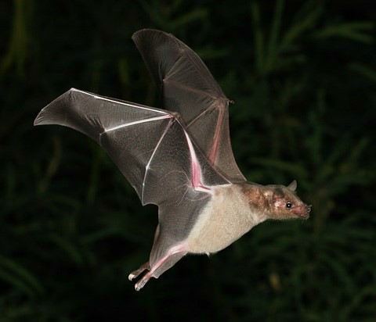

Barn owl Fact File
- Barn Owls hunt at night, and although they have very good eyesight, they rely mostly on their sense of hearing.
- Barn Owls eat mainly small mammals like voles, shrews and mice. Prey is often swallowed whole and indigestible parts are then regurgitated in the form of a pellet.
- Barn Owls do not hoot - they screech.
- The latin name for Barn Owl is Tyto alba alba.
- Owl ears are located one higher than the other, increas- ing sound reception.

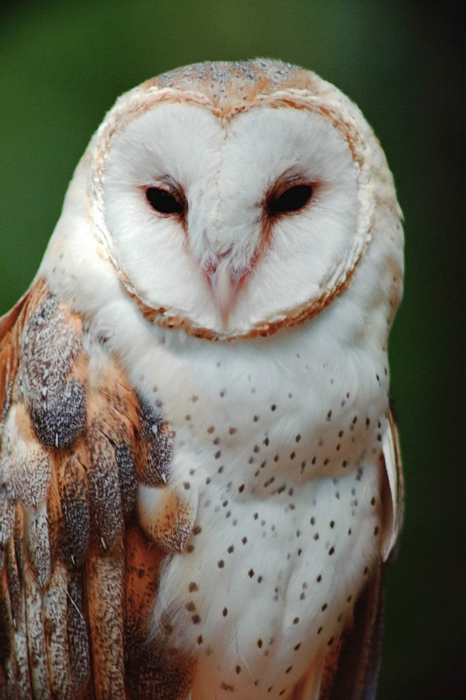
  - Barn Owls have remarkably long legs, toes and talons ena- bling them to catch prey at the base of deep vegetation.
  - During flight, the left ear captures sounds below while the right ear focuses on sounds from above.
  - The feathers on the edge of the Barn Owls' face create a disc, which works to trap and focus sound, rather like our outer ears.
- On average a wild Barn Owl eats about 4 small mammals per night, that's 1,460 per year.

