How to make a puppet theatre

You will need
- Large cardboard box
- Pencil and Ruler
- Scissors
- Stanley knife
- Tape
- String
- 2 pillowcases for curtains
- Craft glue

Instructions

- Draw a square window at the front of the box

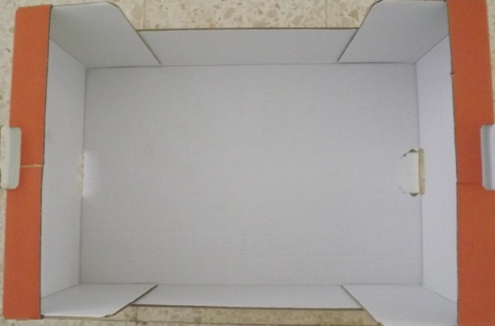

- With a piece of board underneath the area to be cut out, carefully cut the opening with a Stanley knife or scissors. Children should be a safe distance away while this is being done.
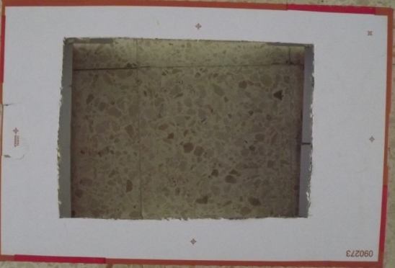
- Paint the box with bright colours.
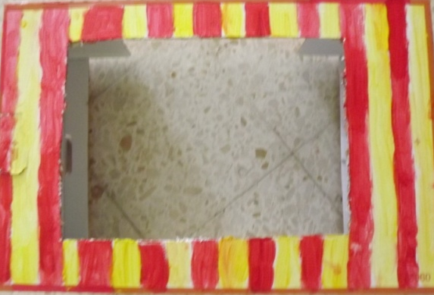

- Use different materials to decorate, e.g. felt, tissue paper or craft foam
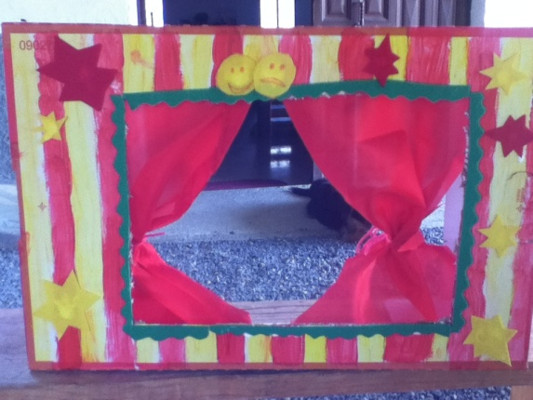
- For curtains, use one pillow case, cut the side and top of the case and then fold fabric out flat to make a larger piece of fabric. Use tape to stick the curtains to the inside of the window and tie with string

- Well done - next you can make puppets!

