Thursday 11th June 2020
Year 1
Phonics  English | See which Phase 5 phonemes you can remember in this Flashcard game:  https://www.phonicsplay.co.uk/member-only/FlashcardsTC.html  Alternative spellings for ‘igh’  Investigation time:  Have a go at the Phoneme Spotter, Word Sort and Best Bet activities in this activity:  https://www.phonicsplay.co.uk/member-only/ighAltSpellings.html?  Watch the third video of the week where I (Miss Gannon) read you the next part of the story!  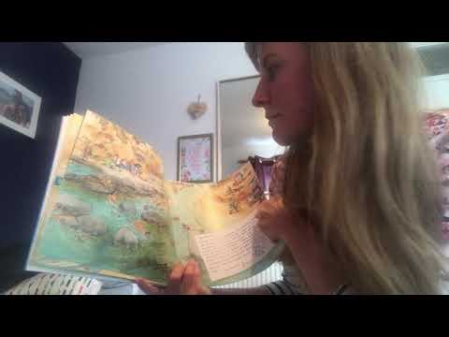  Bonus challenge for today, find out about Leafy Sea dragons!  Year 1: So today the family went on a diving adventure!  Your task for today is to find out what equipment Sea Divers need to wear so that they can dive safely in the water.  This video shows some equipment and explains why they are needed: https://www.youtube.com/watch?v=dalk7rCrjXE  Once you know what to wear, imagine that you have gone scuba diving in Crabby Spit (use the picture to help you) and tell me what you saw on your diving adventure! This could be written as a diary, a video, diary or a letter!
Maths | Division  Sharing  Have a go at answering these questions with an adult to continue thinking about sharing/dividing groups of objects.  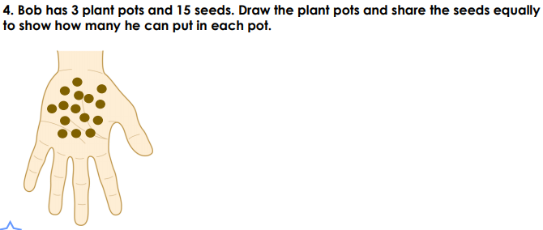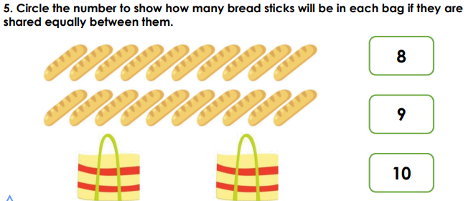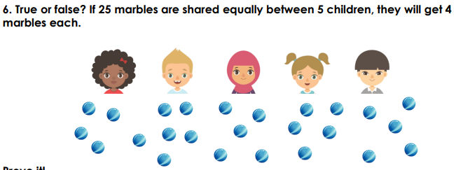  Let’s Solve a Problem!  Click on the link below to help share the biscuits!  Lots of Biscuits  https://nrich.maths.org/6883&part=  Can you read the story and share the biscuits that have been baked between the people who want a taste?
Topic | Punch and Judy Puppet Shows  Entertainment at the Seaside has changed over the years. Today we are going to be looking at puppet shows.  Punch and Judy is a traditional, popular, puppet show featuring Mr Punch and his wife, Judy. You may have seen a show at the seaside as it is a traditional form of children’s entertainment. Traditionally the characters do very funny things and the audience even can join in!  Have a look at the silent Punch and Judy show here which was filmed in 1901! https://www.youtube.com/watch?v=syJC7S3_4yg  Can you find any more videos of Punch and Judy puppet shows?  Your mission today is to make your very own puppet theatre! There is a set of instructions attached if you need a bit of inspiration!  Have a go at acting out a scene in your theatre too – I’d love to see your performances on Class Dojo!

