Wednesday 10th June 2020
Year 1
Spellings | (I’m not sure if I’ve already posted these this week or not, so sorry if I have and you’re seeing them again!)  Alternative spellings for ‘igh’  Light, pie, lie, bike, sky, slide, right, kite, fry, cry  Alternative spellings for ‘oa’:  Potato, grow, loaf, bone, home, woe, tomato, show, superhero, superheroes
Phonics/English | Watch the second video of the week where I (Miss Gannon) read you the next part of the story!  For an extra challenge today, find out what an axolotl is!  Year 1: The weather has changed in Crabby Spit and it is suddenly very windy indeed!  Dad is inviting everyone to a party and is going to buy some fish and chips too! What else might they do at the party? Draw a picture of what you think the party might look like and then write a set of instructions to show what Dad needs to do to set up the party.  Remember to use those ‘door’ words to help you sequence your writing: first, next, then, afterwards, etc.  (Adults: The reason I refer to these words as ’door’ words’ is purely because at school they are displayed on our working wall on pictures of doors.)
Maths | Division  Grouping  Following on from yesterday’s lesson where we shared groups of objects into equal groups so that it was fair, today we are going to continue with this idea of grouping objects. Grouping objects makes it a lot easier to count to find totals and allows you to see if things will be fair or unfair if the total is shared.  Watch this video which talks about sharing and grouping: https://open.online.clickview.co.uk/libraries/categories/26204561/videos/6683530/division-sharing-and-grouping  Have a go at these questions with an adult to look at grouping sets of objects: 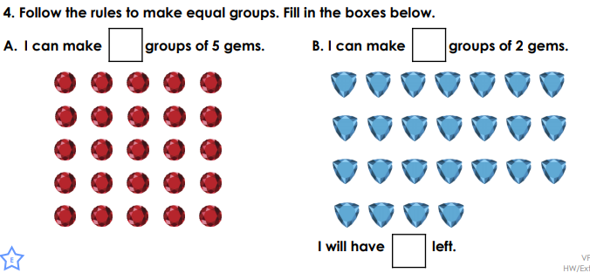 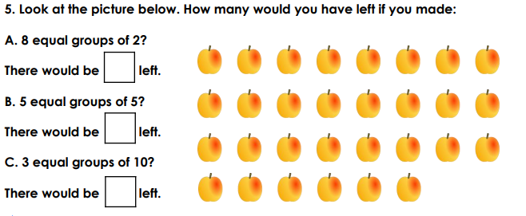 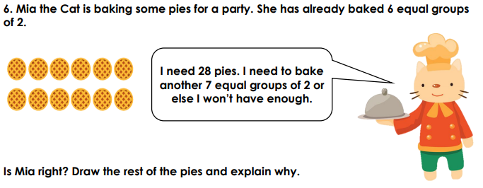  Have a go at the activity sheets attached, begin with Step 1 and select your level (Look at the bottom left hand corner at the letters D = Developing (Easier) E = Expected (Middle) DG = Greater Depth (Harder)) then move on to step 2 and select your level.
Topic | Modern day Seaside Holidays  Listen to Magic Beach being read by the author here:  https://www.youtube.com/watch?v=o_EpPUoEGfc  What sorts of things do they get up to at the beach in the story?  Where might people stay when they go on a seaside holiday?  Hotels  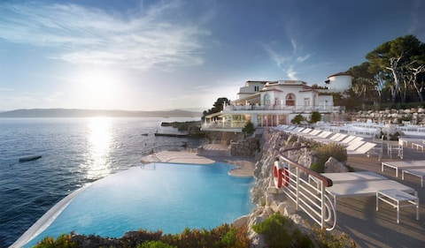  Cottages  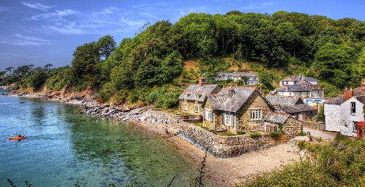  Caravan  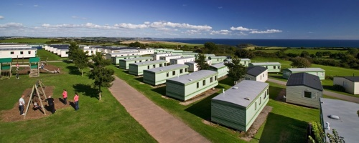  Tents  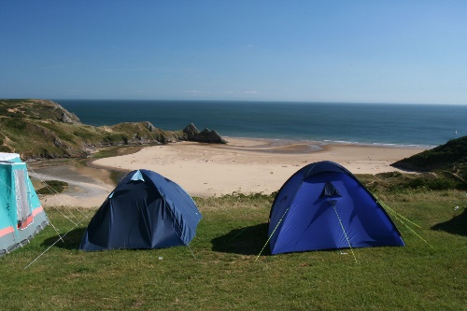  Can you think of any more?  Which would you prefer to stay in?  Create a timetable of what you would plan to do if you stayed in one of these types of accommodation. Would it be different if you were to stay in a different type of accommodation?

