Wednesday 10th June 2020
Reception
Phonics  English | Play phonics tic tac toe with these sounds:  er, air, oa, ure, ow (repeat the sounds in each of the boxes to practise these sounds)  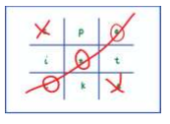  Reading Two Syllable words  Practise clapping to one syllable words – model one clap for each of these words (it would be a great idea to show the objects too) cup, shoe, clock, tea, tree  Then model clapping to words with two syllables: coffee (co-ffee), table (ta-ble), sofa (so-fa). Ask your child to find another example in the house. Encourage them to clap the sounds.  Then have a go at reading these two syllable words – encourage your child to split the word into two parts – by clapping the syllables first.  Chicken, tonight, boatman, rooftop, farmyard, market, lightning, bedroom  Watch the second video of the week where I (Miss Gannon) read you the next part of the story!  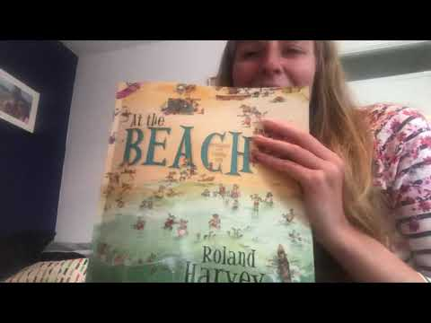  The weather has changed in Crabby Spit and it is suddenly very windy indeed!  Dad is inviting everyone to a party and is going to buy some fish and chips too! What else might they do at the party? Draw a picture of what you think the party might look like and label each part of the party using phonics sounds you know. Remember to split words into smaller parts using phoneme fingers! 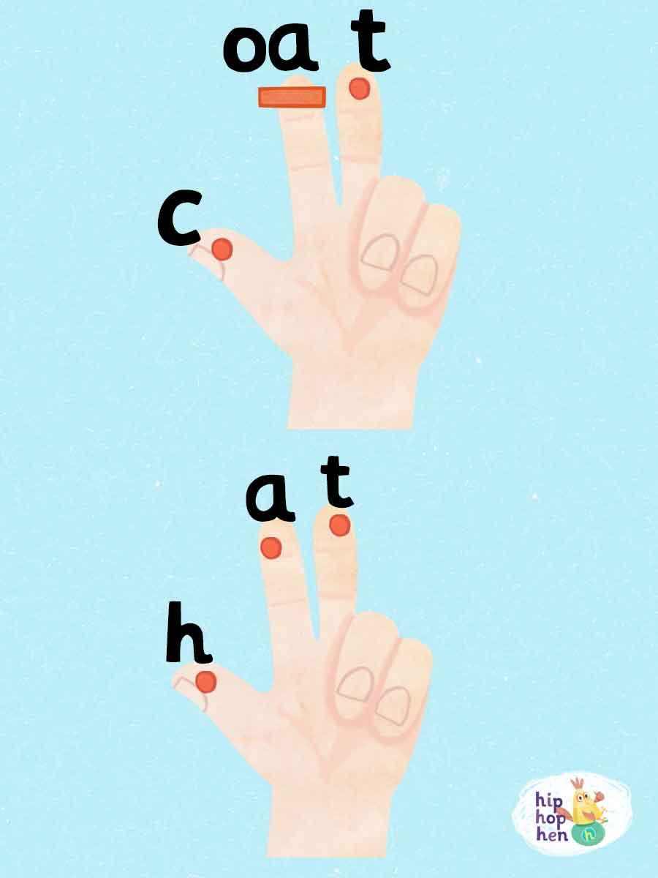
Maths | Patterns – creating & spotting  Join in with this very catchy song and dance about patterns: https://www.youtube.com/watch?v=BQ9q4U2P3ig  Can you complete the repeating patterns in these activities:  Easier (2 part repeating): https://kids.classroomsecrets.co.uk/resource/reception-repeating-a-pattern-game/  Trickier (3 part repeating): https://kids.classroomsecrets.co.uk/resource/reception-repeating-a-complex-pattern-game/  Pattern Headbands  Cut a strip of paper which will be used as a headband.  Your job is to make a repeating pattern on your headband which you can wear for the rest of the day!  Start with something a little simpler if you’re wobbly:  Then move on to something a bit trickier if you’re getting the hang of it:
Topic | Modern day Seaside Holidays  Listen to Magic Beach being read by the author here:  https://www.youtube.com/watch?v=o_EpPUoEGfc  What sorts of things do they get up to at the beach in the story?  Where might people stay when they go on a seaside holiday?  Hotels  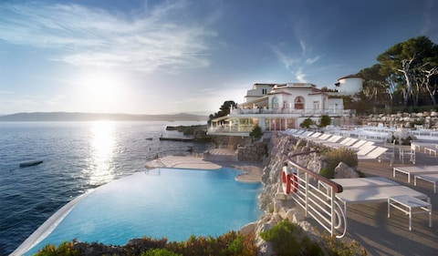  Cottages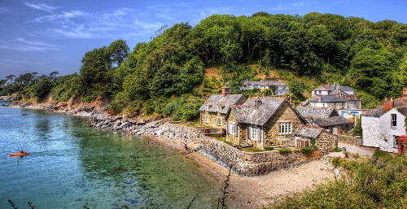  Caravan  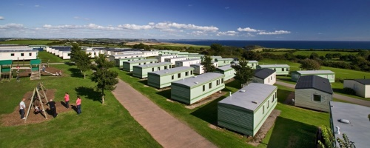  Tents  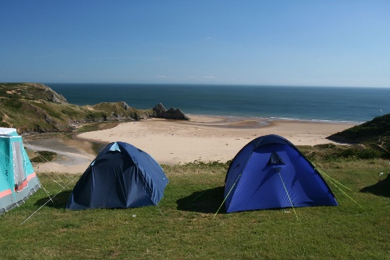  Can you think of any more?  Which would you prefer to stay in?  Create a timetable of what you would plan to do if you stayed in one of these types of accommodation. Would it be different if you were to stay in a different type of accommodation?

