Tuesday 9th June 2020
Year 1
Phonics  English | Sentence Substitution  Words in sentences can be changed to change the meaning of the sentence.  See if you can make new sentences out of the words given in the first sentence (click Menu then select 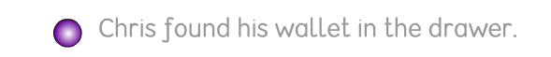)  https://www.phonicsplay.co.uk/member-only/SentSubPhase5b.html  Guidance: If the link does not work, go onto the Phonics Play website and click phase 5 – scroll down to 5B - click sentence substitution  Alternative spellings for ‘oa’  Can you remember any other ways of spelling the ‘oa’ sound? (answers: o-e, ow, oa, o)  Quick fire spelling test, can you remember the correct ‘oa’ spelling for each of these words:  told, hold, gloat, boast, don't, won't, stone, throne, blow, snow  Practise reading the following sentences:  The boasting toad spoke boldly to a mole.  I won't throw a stone if it is cold.  Will you hold some soap, put it in a bowl or hang it on a rope?  Watch the first video of the week where I (Miss Gannon) talk to you a little more about the story and Postcards!  For today’s task, you are going to have a look at the photo taken of the people enjoying their time at the beach.  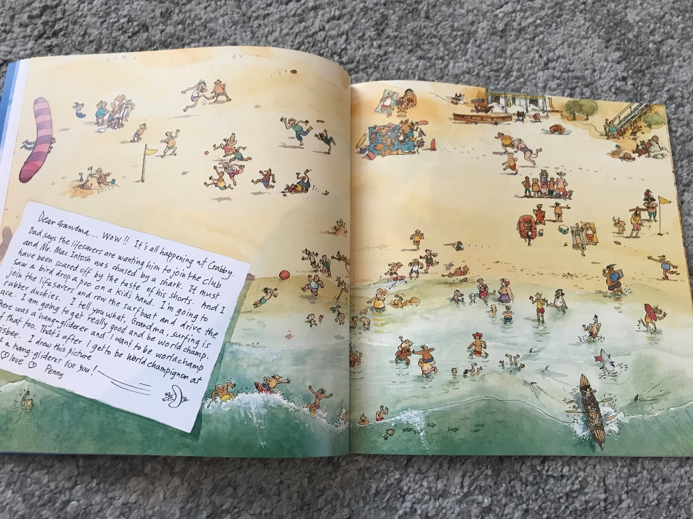  Year 1: Make a list of 5 different events which might happen when they are on the beach. They could be silly or sensible, it is up to you but remember to look at the picture to help you decide what you would write about in your postcard.  Then, when you have decided on your 5 things, put them in an order of when they might happen.  Here are my ideas:  A seagull stole my sandwich when we were enjoying the picnic.  A frisbee hit me on the head when I was sunbathing  We rowed a boat against the waves.  We took a family photo on the beach  We played mini golf and my ball got sucked into the sand!  Once you’ve organised your events, have a go at writing them on a postcard in chronological order (the order they happened in). Remember to summarise your whole day in the first sentence and draw little pictures on your postcard too, just like in the book!  Once you’ve done that, you can draw a picture of Crabby Spit on the back, just like a real postcard!
Maths | Multiplication  Equal Groups  How would you feel if your friend shared their favourite sweets out between you and your friends and your friends got 4 each but you only had 2? It might not seem fair, right? Well that’s why we need to make sure we group objects into equal groups.  First off, have a go at answering these questions:  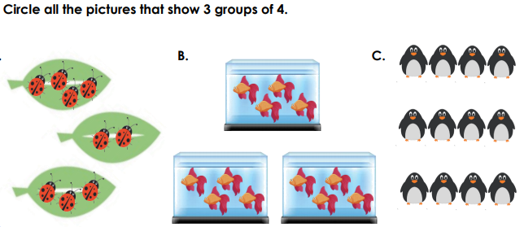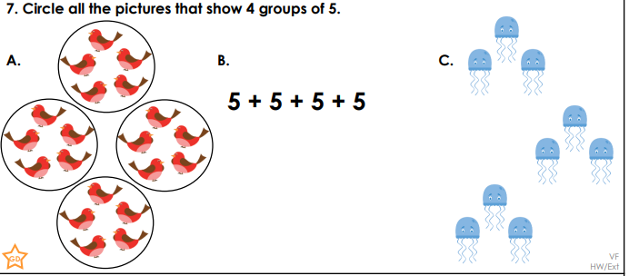  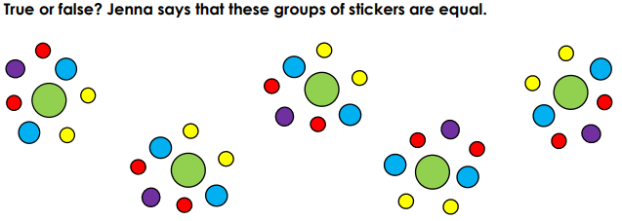  Using Lego, counters, cereal or any other individual items you have at home, explore making equal groups which fit these descriptions:  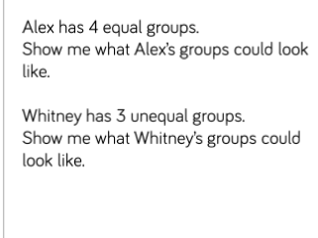  Are there any quantities of objects which could work for both Whitney and Alex’s statements?
Topic | Let’s explore the seaside!  Today we are going to look at Seaside towns in the United Kingdom  Brighton  Take a look at the photo comparisons of Brighton in 1900 and 2020!  Blackpool  Take a look at this video of Blackpool Promenade in the 1900s https://www.youtube.com/watch?v=ctSWBvyzSIs  Can you find these seaside towns in the UK?  Portsmouth  Newquay  Great Yarmouth  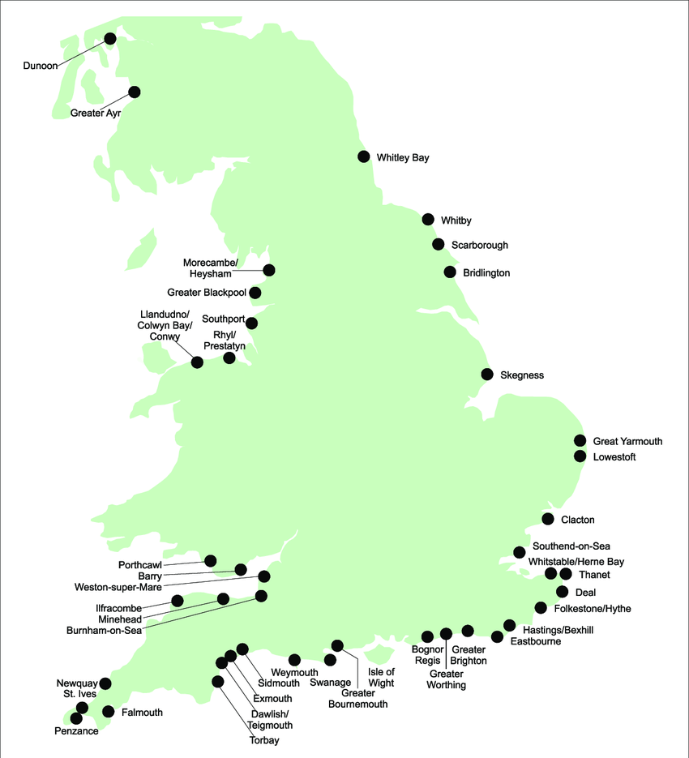  What can you do at the beach? What can you see in modern day seaside towns?  Art focus: Waves Breaking by Claude Monet  What can you see in this piece of artwork? How does it make you feel?  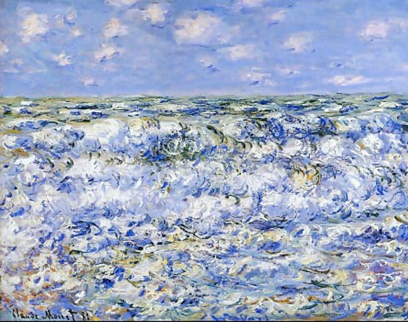  Can you recreate Monet’s piece or put your own spin on it?  Monet made the piece of artwork using Oil Painting, could you recreate it using paper to make a collage, or even sponge painting?

