Watch the first video of the week where I (Miss Gannon) talk to you a little more about the story and Postcards!

What can you see happening in the picture?

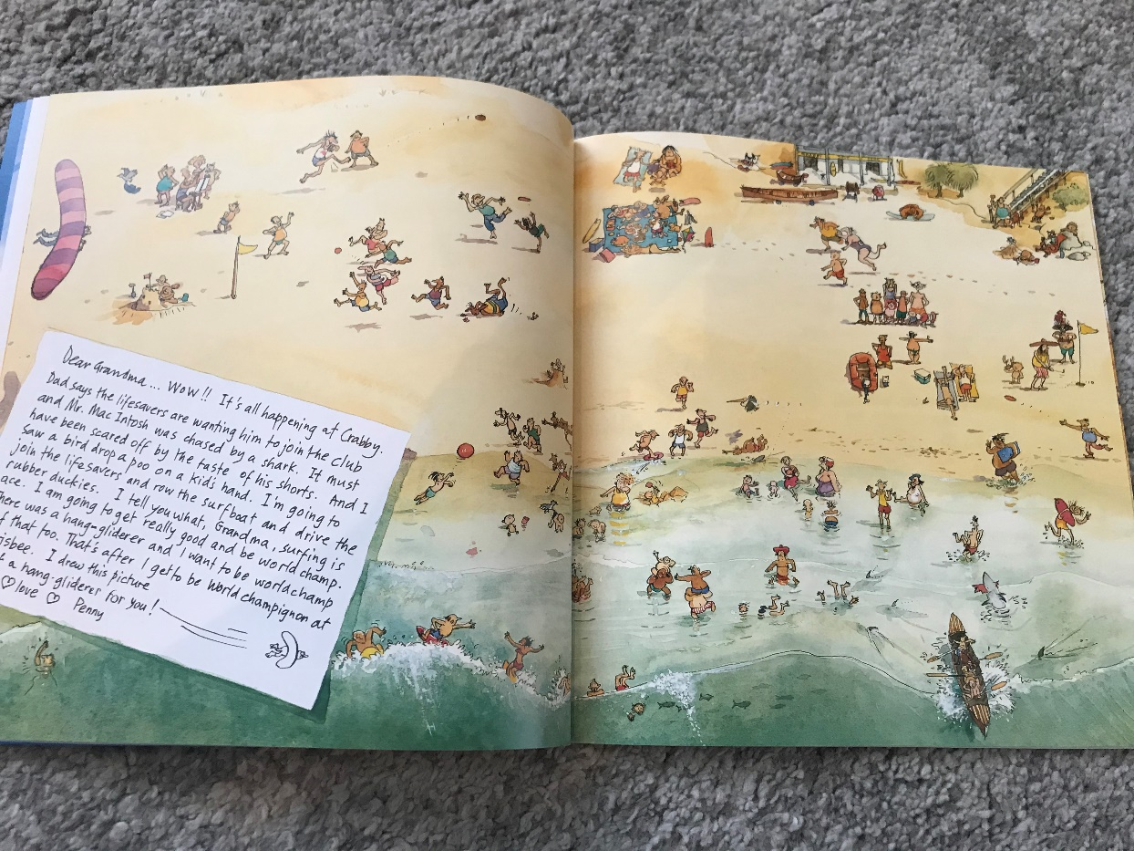

Can you see the hang glider in the sky? Dont they look amazing!

Learn more about hang gliders in this video: https://www.youtube.com/watch?v=DW6_L2EsVCc

Have a go at writing 2 captions for things you can see happening in the picture! Draw a picture to go alongside each of your captions too! You might like to write about some new hang glider facts you have learned!

Maths | Symmetry  Rewatch the NumberRock video to remind yourself what symmetry is: https://www.youtube.com/watch?v=SJlhywRfvh8  The opposite of Symmetrical is Asymmetrical, this is where objects do not have lines of symmetry (don’t look the same). Can you sort the pictures into Symmetrical and Asymmetrical on the activity sheet attached?  Building: Using Lego, wooden bricks or anything else you have at home, could you build a street of 5 symmetrical houses/towers? Remember they need to look exactly the same from the front. Here’s an example:  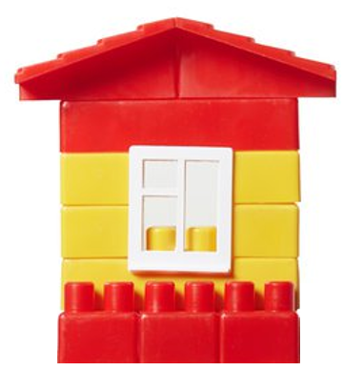
Topic | Let’s explore the seaside!  Today we are going to look at Seaside towns in the United Kingdom  Brighton  Take a look at the photo comparisons of Brighton in 1900 and 2020!  Blackpool  Take a look at this video of Blackpool Promenade in the 1900s https://www.youtube.com/watch?v=ctSWBvyzSIs  Can you find these seaside towns in the UK?  Portsmouth  Newquay  Great Yarmouth  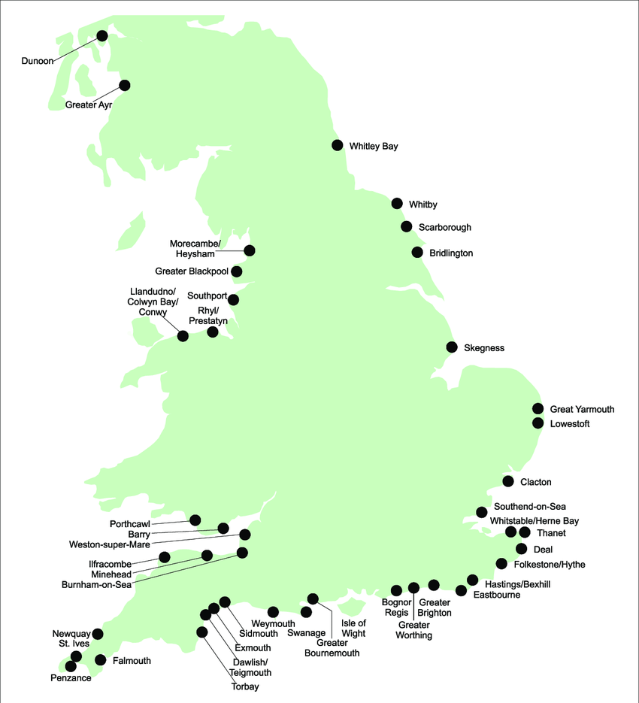  What can you do at the beach? What can you see in modern day seaside towns?  Art focus: Waves Breaking by Claude Monet  What can you see in this piece of artwork? How does it make you feel?  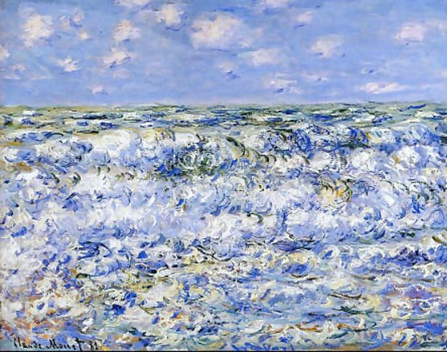  Can you recreate Monet’s piece or put your own spin on it?  Monet made the piece of artwork using Oil Painting, could you recreate it using paper to make a collage, or even sponge painting?

