Monday 8th June 2020
Year 1
Phonics/English | Take a look at the map of Crabby Spit (which is taken from a story we are going to be reading this week). Crabby Spit is a place which has been designed to be set in Australia.  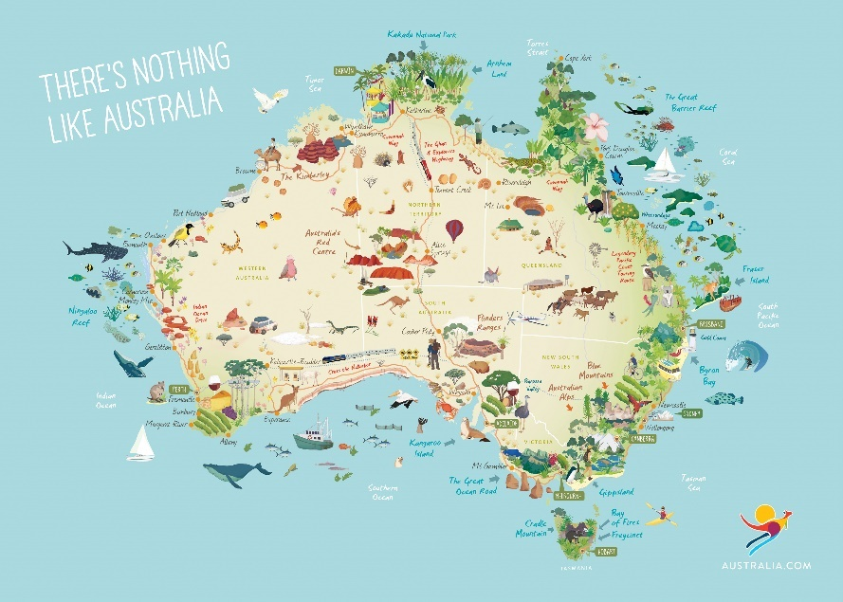  The map is created by a family who visit Crabby Spit for their holidays and jot down their memories of different parts they have visited.  Year 1: Can you design a tour of Crabby Spit for Rowan Class to visit some of your favourite parts of the map? Where would we go and what would we see in the places you have chosen?  Once you’ve created your Crabby Spit Tour, use the picture of the map to answer the questions attached.
Maths | Multiplication  Counting in 2s, 5s, 10s  Watch these videos showing the 2, 5 and 10 times tables!  https://open.online.clickview.co.uk/libraries/categories/26204561/videos/25918390/2-times-table  https://open.online.clickview.co.uk/libraries/categories/26204561/videos/25923580/5-times-table  https://open.online.clickview.co.uk/libraries/categories/26204561/videos/25923529/10-times-table  If you have a handful of 2ps, 5ps and 10ps these would be useful to aid the counting in these multiples.  Fill in the missing numbers in these sequences:  2,4,6 ___ 10, 12, 14, 16, ____, 20  5, 10, 15 ____, 25, 30, 35, _____, 45, 50  10, 20, 30, 40 ____, 60, 70 _____, 90 ______  (Adults: Just for your reference, the children have been counting in 2s, 5s and 10s whilst they have been in Year 1, today they are developing the idea that we can write these as multiplication sentences e.g. 5 x 4 = 20)  Have a go at the sheets attached to practise drawing jumps on number lines to show that you are counting in groups of 2s, 5s or 10s.  There is an extra challenge attached if you wish to have a go at that too!
Topic | We’re going on a Summer Seaside Holiday!  Let’s pack our bags to begin with! What might we want to take with us on our Seaside Holiday? There is an empty suitcase attached if you would like to use it  We are stepping back in time for today’s lesson. We are now in the year 1900 which is 120 years ago!  First of all, we are going to the train station to begin our journey to the seaside!  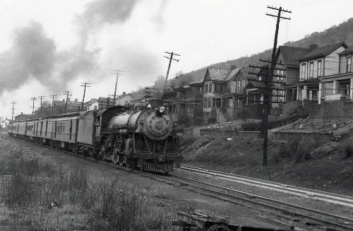  …and we have arrived!  Watch this video to begin to understand what the seaside might have felt like! https://www.youtube.com/watch?v=zWgnpY4L9so  Have you ever visited any beaches in the UK? Make a list of them and see if you can find them on Google maps!  What memories do you have of the beach? Was there any sand? How did it feel under your feet? Did you enjoy any delicious food at the beach?  Why do you think people enjoy going to the seaside?  Year 1: Write down 5 things you noticed in the video that are different to how the seaside looks to us in modern times.

