Monday 8th June 2020
Reception
Phonics  English | Make a Match: https://www.phonicsplay.co.uk/member-only/MatchingPh3Wk4.html  (When on the website, Click phase 3 – Make a Match if the link doesn’t work)  This is a game of memory! Click on a card at a time and see if you can match the picture to the correct word.  Sentence Substitution  In some sentences, words can be swapped to change the meaning of the sentence. Like: The mug is on the table. could turn into: The laptop was on the table  Write each of these words for each set colour on separate cards, then see which new sentences you can make:  You can hear a goat. – toad – song – see – coin  They might meet in the town. – market – summer –we – fish  The shop is on the corner. – church – right – shark – boat  Take a look at the map of Crabby Spit (which is taken from a story we are going to be reading this week). Crabby Spit is a place which has been designed to be set in Australia.  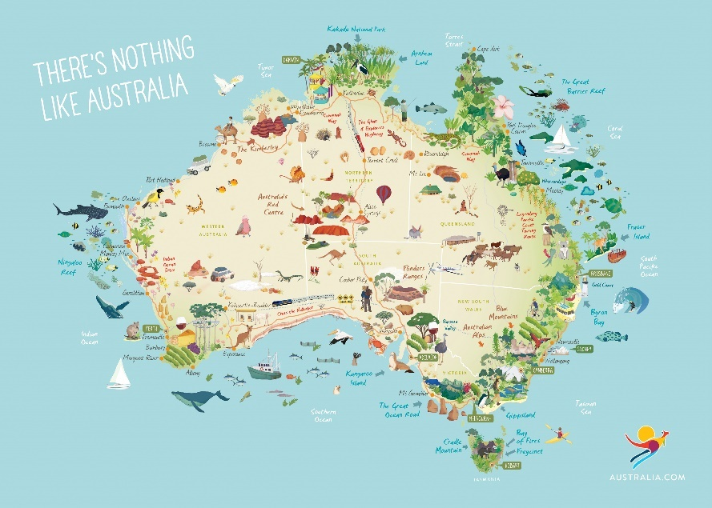  The map is created by a family who visit Crabby Spit for their holidays and jot down their memories of different parts they have visited.  The family go on lots of adventures in the story and see lots of creatures on the way.  Here are some pictures of a few of the creatures that the family have seen in Crabby Spit.  Soldier Crab:  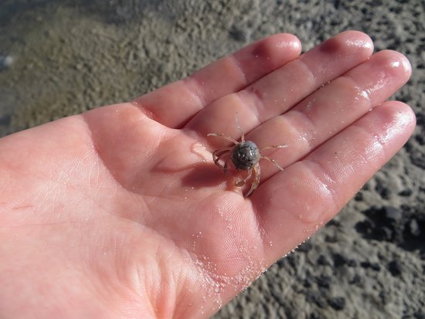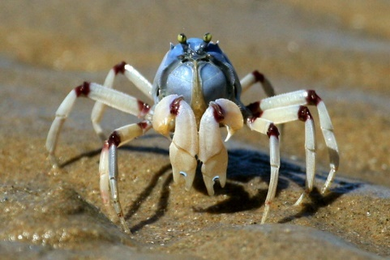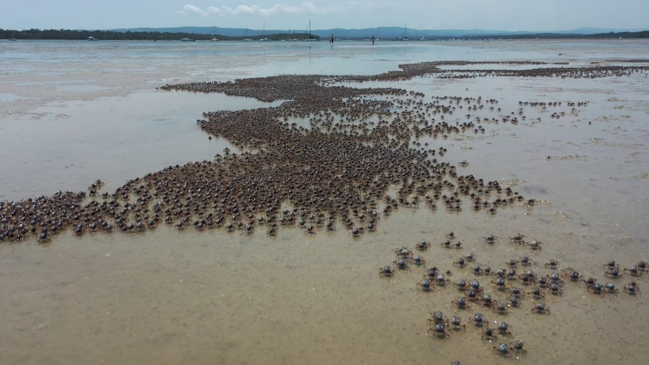  Look at how many Soldier Crabs are in this picture!  Mussels  z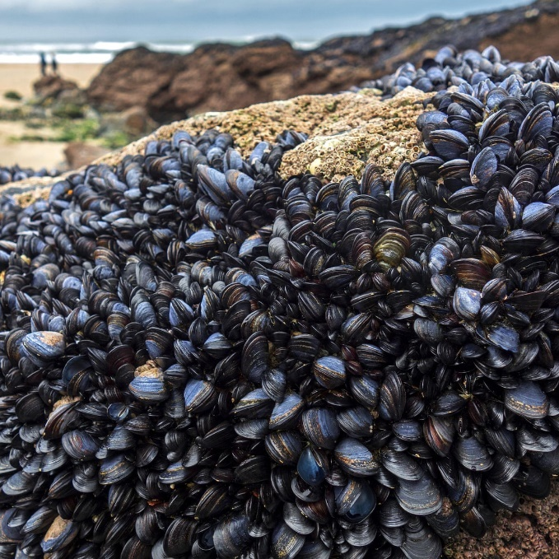  Leafy Sea dragon:  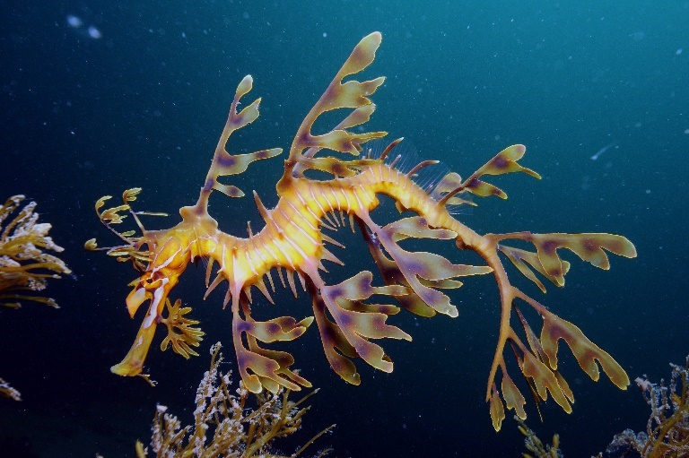  Stingray  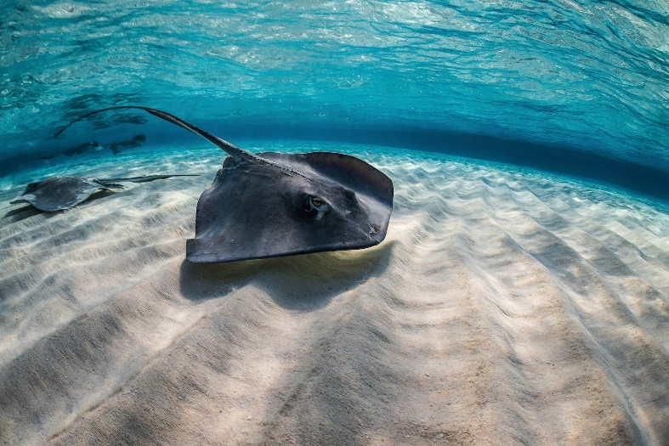  The family even know where the Pirate Cave is! I wonder what the Pirate Cave looks like!  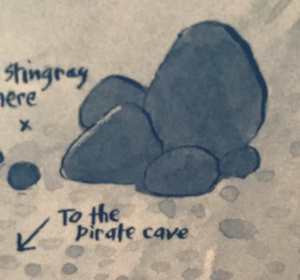  Your task: Can you draw or make your very own Pirate Cave. What do you think we will find there? Will there be any of these sea creatures lurking around? Might there be any pirates too?
Maths | Symmetry  Turn it Over!  For today’s starter you will need the numbers 0 – 20 written on individual pieces of paper laid out around you.  An adult will shout a number between 0 and 20 and you will have 5 seconds to find the number and turn it over! Continue until all of the numbers have gone. (Adults: start with the larger numbers as these are trickier to find first with a larger group of numbers available).  Video about Symmetry:  Listen to this NumberRock song showing shapes with lines of symmetry in them:  https://www.youtube.com/watch?v=SJlhywRfvh8  Let’s Look!  Have a look around your house and neighbourhood for objects which are symmetrical! Take a photo of each one you see and create a collage of the photos (on your phone) and upload to Dojo so I can see what you found!  Look at these pictures of symmetrical flowers: 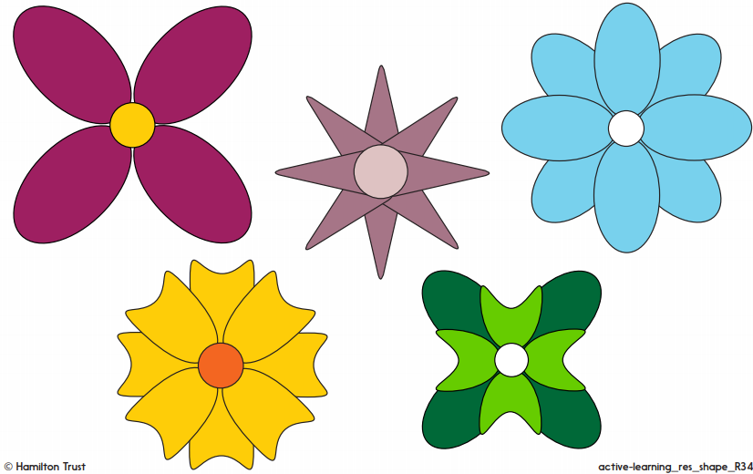  Flowery Maths:  Find some flowers outside which look exactly the same shape/size.  Make a symmetrical picture using what you have found with a line of symmetry down the middle:  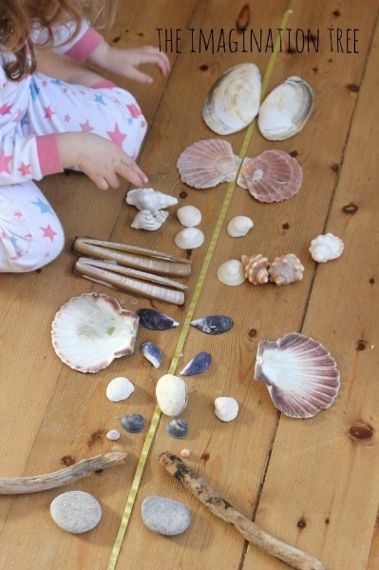
Topic | We’re going on a Summer Seaside Holiday!  Let’s pack our bags to begin with! What might we want to take with us on our Seaside Holiday? There is an empty suitcase attached if you would like to use it  We are stepping back in time for today’s lesson. We are now in the year 1900 which is 120 years ago!  First of all, we are going to the train station to begin our journey to the seaside!  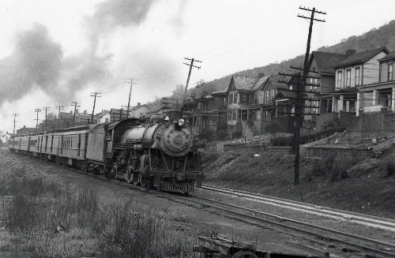  …and we have arrived!  Watch this video to begin to understand what the seaside might have felt like! https://www.youtube.com/watch?v=zWgnpY4L9so  Have you ever visited any beaches in the UK? Make a list of them and see if you can find them on Google maps!  What memories do you have of the beach? Was there any sand? How did it feel under your feet? Did you enjoy any delicious food at the beach?  Why do you think people enjoy going to the seaside?  Reception:  What does this bathing machine remind you of?  Why does it need wheels?  Would you like to use a bathing machine?  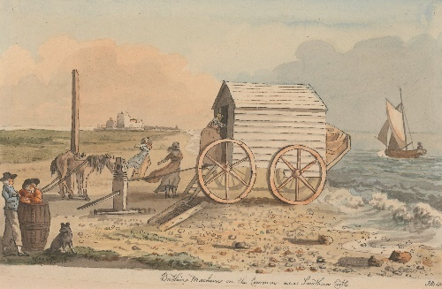  Can you design your own modern day bathing machine? You could draw it, or build it using Lego!

