Friday 5th June 2020
Year
Phonics  English | -Alternative spellings for ‘m’  -Practise reading tricky words: thought, through, work, mouse  https://new.phonicsplay.co.uk/resources/phase/5/train-your-brain-ph5 (Click choose words, then select Phase 5b from the bottom of the screen, then select the 4 words above)  -Practise writing sentences with alternative ‘m’ spellings (adults: read the sentences and ask your child to write them):  A small crumb is under my thumb.  Swimming makes my toes go numb.  This summer, my mum met a mouse  Watch the last video of the whole story. Did you notice that the bus didn’t leave the child’s house? Take a look back at the pictures and find out for yourself!  Year 1: Write a book review about the story now that we’ve finished it. There’s a template attached if you wish to use it.  Extra challenge: Did it remind you of any other stories you’ve read?  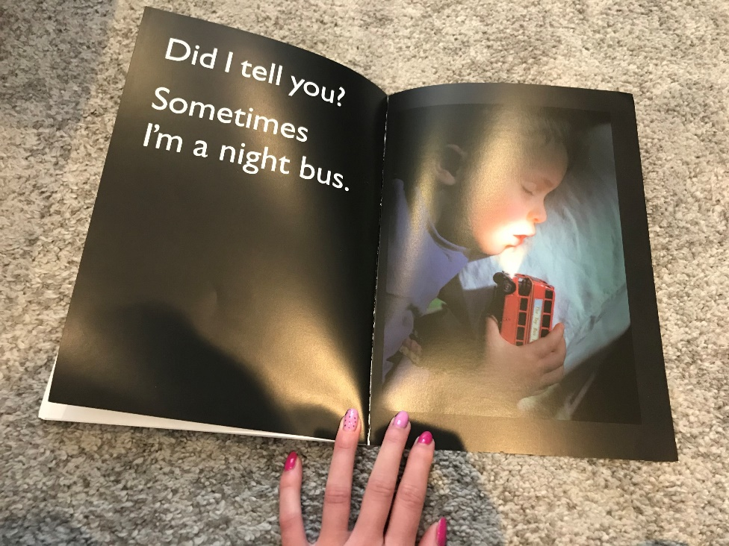  What adventures do you think the bus might get up to at night?
Maths | Patterns of 2D & 3D shapes  1 minute challenge – Draw your own shape pattern.. but your pattern needs to be a 3 or 4 part repeating pattern!  Spend a few minutes on these activities reminding yourself how to make repeating patterns:  https://kids.classroomsecrets.co.uk/resource/repeating-patterns-video-tutorial/  https://kids.classroomsecrets.co.uk/resource/reception-complex-repeating-patterns/  https://kids.classroomsecrets.co.uk/resource/reception-repeating-patterns-game/  Once you’re confident, have a go at the 2D and 3D shape pattern activity attached.
Topic | R.E  Hanukkah  Learn about Hanukkah in this video: https://open.online.clickview.co.uk/libraries/categories/26204711/videos/8733823/hanukkah  Does this celebration remind you of any other religious celebrations/festivals we have already learned about? What about The Last Supper? What about Christmas? What about the Easter Story?  Have a go at one or more of the activities attached, you could have a go at baking/making some Latkes, you could play a game of Dreidel or make your own Menorah!  Learn about why Hanukkah is a special time for people who celebrate it: https://www.bbc.co.uk/newsround/35030671  Dramatize it!  If you have enough people at home (or you could use some toys you have) have a go at acting out the story of Hanukkah!

