Friday 5th June
Reception
English | Winches – look at the picture of the bus being pulled out of the water!  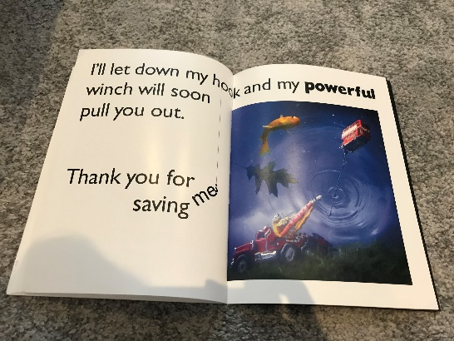. 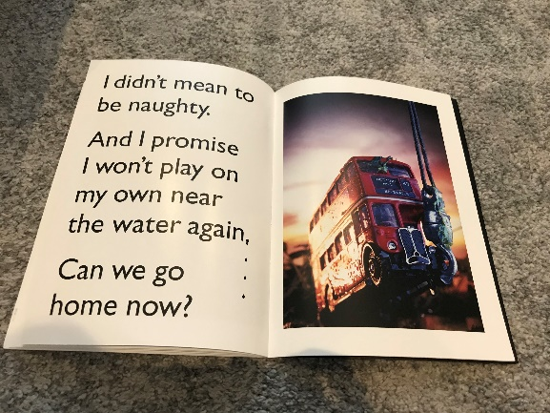  Can you create your own winch to save toys that have fallen into some water you have at home? You could even use magnets if you have any lying around!  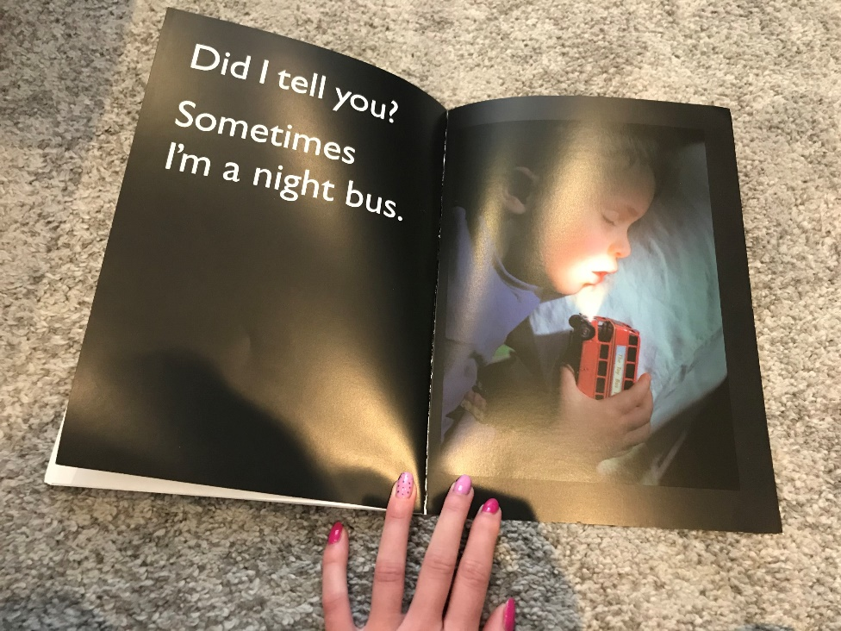  What adventures do you think the bus might get up to at night?
Maths | Directional Language  Watch this video to remind you of positional language and to introduce you to directional language.  https://open.online.clickview.co.uk/libraries/categories/26204561/videos/3712065/position-and-movement  Then have a go at playing Simon Says! The twist with Simon Says today is that all of the things Simon asks should involve directional language, e.g.: Run across the mat, hop to the wall, walk 3 steps behind.  Set up an obstacle course in the garden with some instruction cards (like the ones attached) to practise following instructions!
Topic | R.E  Hanukkah  Learn about Hanukkah in this video: https://open.online.clickview.co.uk/libraries/categories/26204711/videos/8733823/hanukkah  Does this celebration remind you of any other religious festivals we have already learned about? What about The Last Supper? What about Christmas? What about the Easter Story?  Have a go at one or more of the activities attached, you could have a go at making some Latkes, you could play a game of Dreidel or make your own Menorah!  Learn about why Hanukkah is a special time for people who celebrate it: https://www.bbc.co.uk/newsround/35030671  Dramatize it!  If you have enough people at home (or you could use some toys you have) have a go at acting out the story of Hanukkah.

