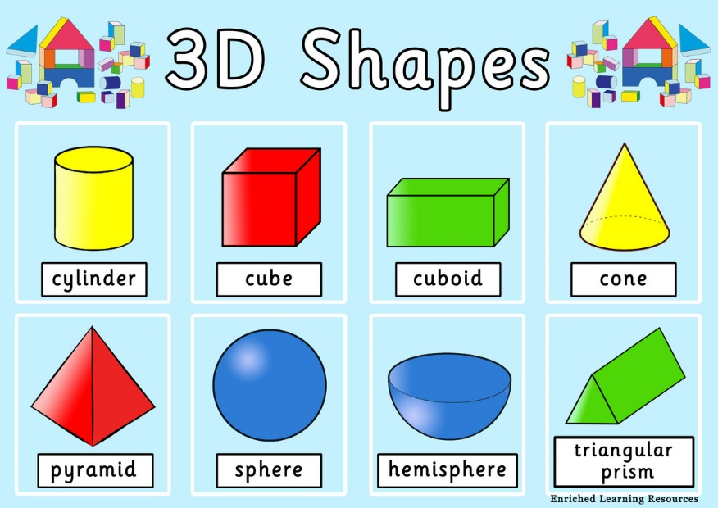

Mystery shapes.
- I have six square faces
- If I am one way up, I slide. If you turn me over, I roll.
- I am used in football!
- I can only slide. Not all my faces are the same but they are all rectangles.

True or false

- No shape has only curved faces
- Two shapes we know have six rectangle faces
- No shape can both roll and slide

Name three shapes which you could use, dipping one side in paint, to print a square.

