Thursday 4th June 2020
Year 1
Phonics/English | Watch todays entry of the Naughty Bus!  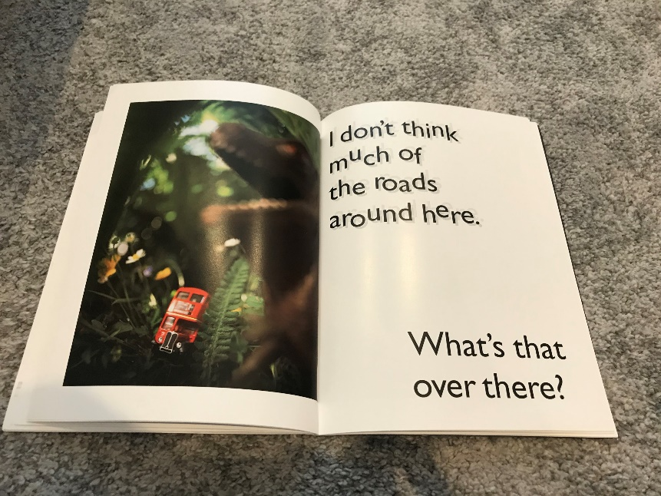  Why do you think the words are shown like this? (To show that the bus is bumping up and down on the grass)  Adjectives  Reminder: Adjectives are describing words: like, small, colourful, plain, loud, soft etc.  Can you make a list of describing words for the picture of the bus when he reaches the pond?  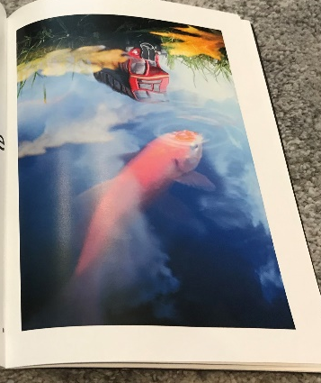  Then use these adjectives in 3 sentences about the picture, bonus points if you are able to use more than 1 adjective in each sentence!
Maths | Sorting 3D Shapes  Now that you are an expert with 3D shapes, let’s see if we can do some sorting! Ready for some quickfire questions…  You have 1 minute to draw/write down as many 3D shapes which have curved edges. GO!  You have 1 minute to draw/write down the names of as many 3D shapes which have at least one squared face!  See if you can solve the mystery 3D shapes in the activity attached.  Today’s task: Choose your level with the activity sheets attached to practise sorting 3D shapes into categories.
Topic | Another method of transport we can use to take us to different places is by airplane!  Listen to this story about a girl who flies over different cities in her airplane: https://www.youtube.com/watch?v=TqTf0zwyVR4  The Wright Brothers were the first people to successfully fly an airplane! Learn about their journey here: https://youtu.be/YDlk4Ky_ahs  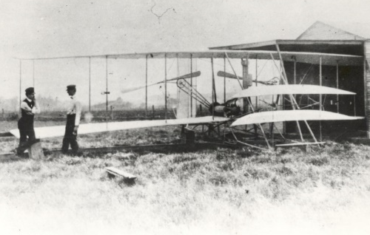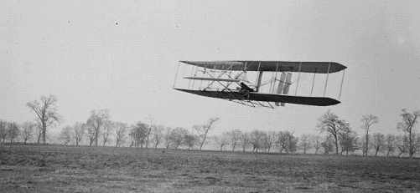  If you have enough space outside, measure a line of 12 metres, this was how big the wings were of the airplane!  If you were able to interview the Wright’ brothers, what would you ask them?  Let’s explore: Today’s challenge is to create 3 different paper airplanes, they all have to be different, here are some ideas: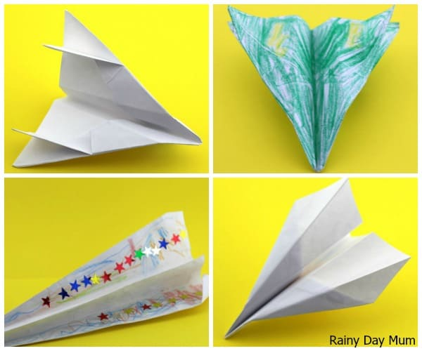  Test each of your airplanes and see which one travels the furthest! I’d love to see some videos of your paper airplanes!

