Wednesday 3rd June 2020
Reception
English | -Watch today’s instalment of Naughty Bus read by Miss Gannon!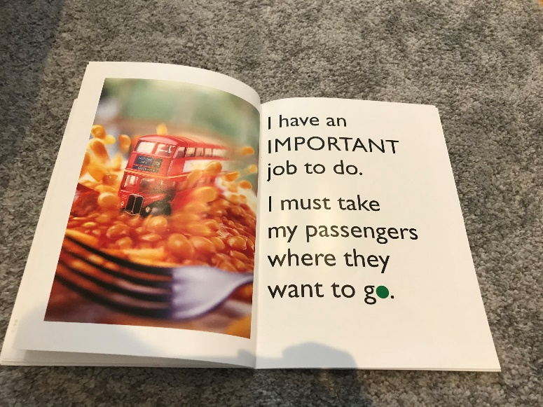  Reception: Can you write a sentence about the bus in the picture? What might happen to the bus now that it’s driven through baked beans – draw a picture of what you think might happen next.
Maths | Sharing  Yesterday we practised halving quantities and amounts, that’s when there’s only 2 people. Today we are going to practise sharing quantities and amounts between more than 2 people!  To remind ourselves of what you did yesterday, have a go at this(some biscuits/round foods would be great for this, if not drawing the biscuits/pancakes would be good too – this would be a fantastic opportunity to do some baking to practise sharing). The idea is for the child to try and share the foods equally between two people (halving). Ensure the children understand that each half should be the same size so that it is fair.  Today’s task: design a pizza!  The mission today is to design a pizza that 4 people can share (so cutting it into quarters) so we need to make sure that the toppings are shared equally. The children can choose whichever toppings they like on their pizza. (There is a blank pizza sheet attached if you wish to use it).
Topic | Trains and Trams  Fun fact: the worst ‘train’ refers to the whole of the locomotive & the coaches/carriages.  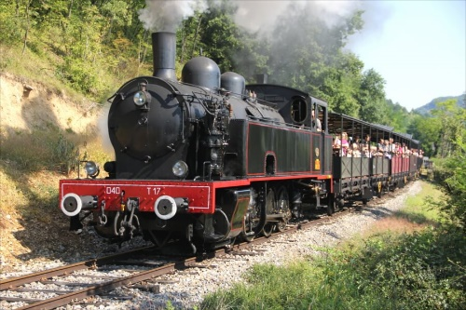  A locomotive refers to the engine that pulls the train.  Take a look at the powerpoint showing how Trains have changed through time. What do you notice?  There are different types of locomotives, some run on coal:  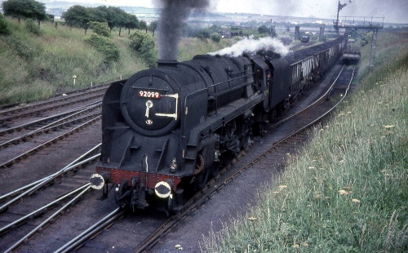  some diesel:  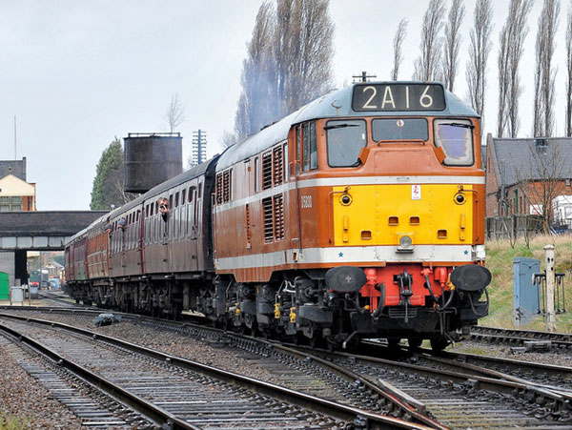  and some on electricity:  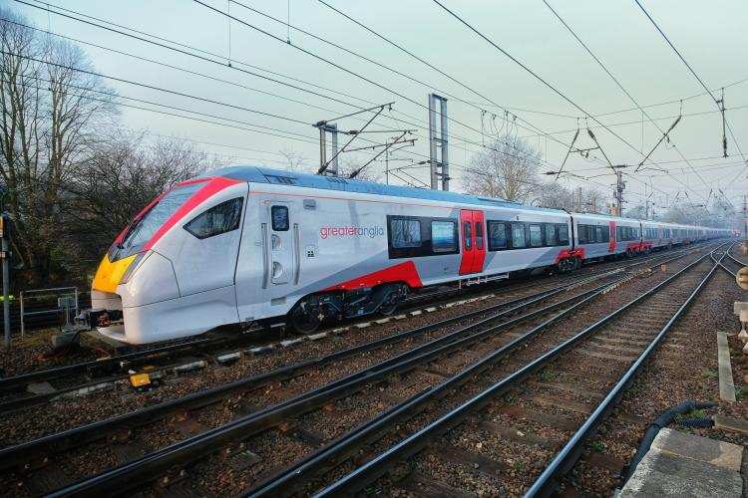  Trams are another type of transport that use electricity too: 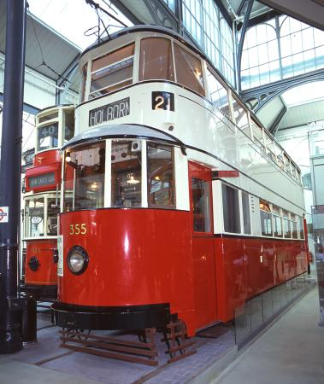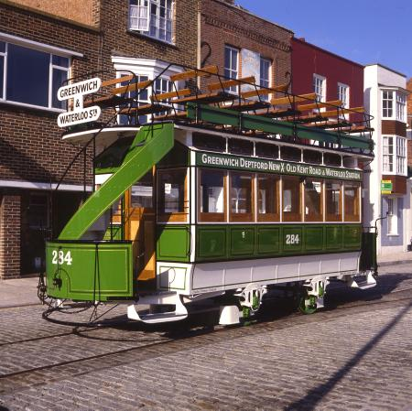  What similarities and differences can you spot between the trams and trains?

