Tuesday 2nd June 2020
Year 1
English | English  Take a look at this page in the story. (Have a go at these questions before watching the video of the story)  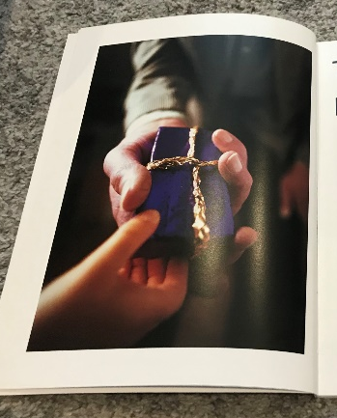  What type of person is giving the gift? (Generous, older, kind etc.)  How do you think the person who is receiving the gift feels?  What might be in the gift?  -Watch today’s entry of Miss Gannon reading the story!  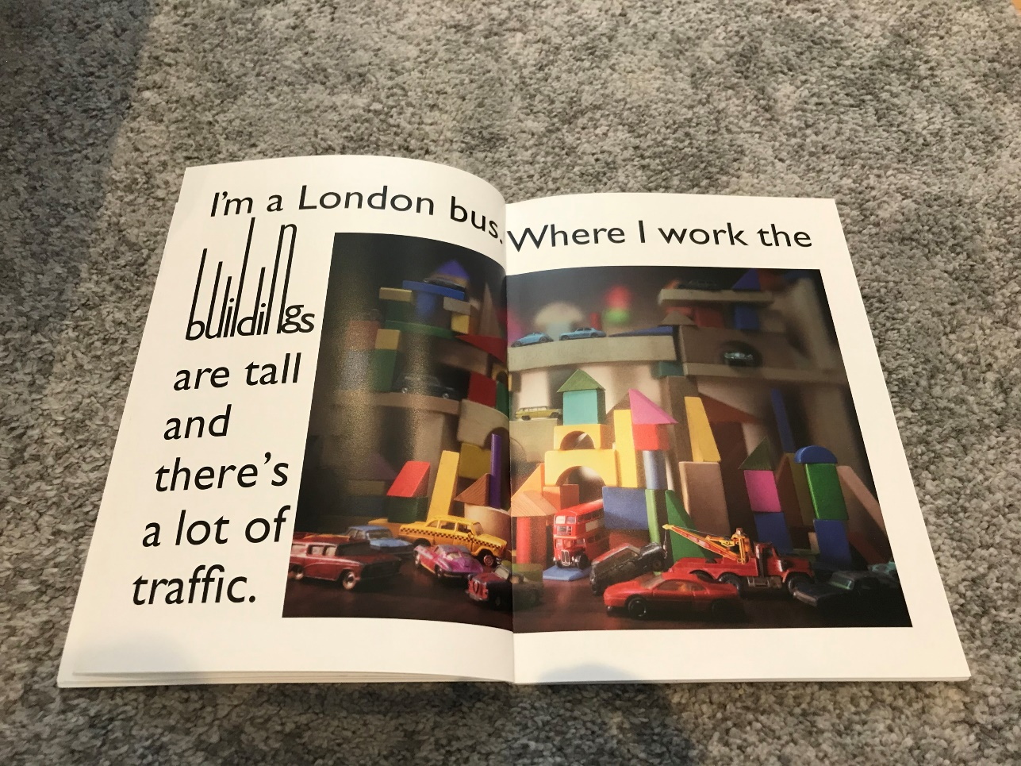  Year 1: Can you write a diary entry from the point of view of the bus talking about what it can see in the city? (Use the picture in the book to help you)  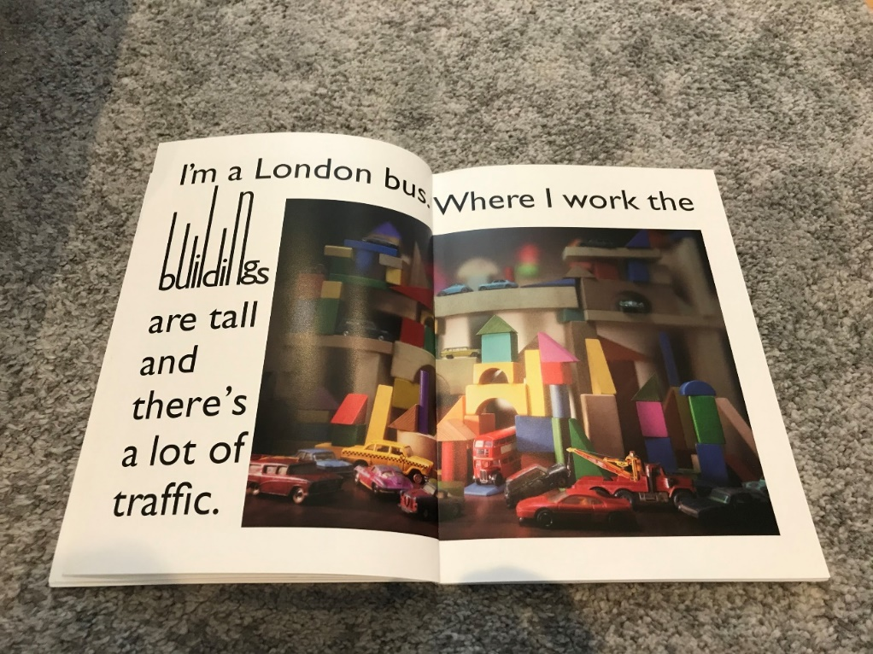
Maths | Year 1 –Sorting 2D Shapes  You have 1 minute to name as many 2D shapes as you can… GO!  You have 30 seconds to name any 2D shape which has a curved face… GO!  You have 20 seconds to name as many 2D shapes with more than 3 sides.. GO!  Have a practise sorting these shapes into categories: 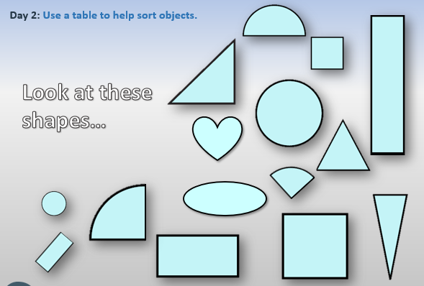  Have a go at sorting the houses in different ways at this website (  https://nrich.maths.org/5157  Then have a go at the challenge sheet with some other sorting tasks on too
Topic | Cars & Buses  Look at the Powerpoint Showing pictures of cars from different years.  If your parents drive, ask them if they have photos of their first cars and see how cars might have changed since then.  Look at this picture of a bus 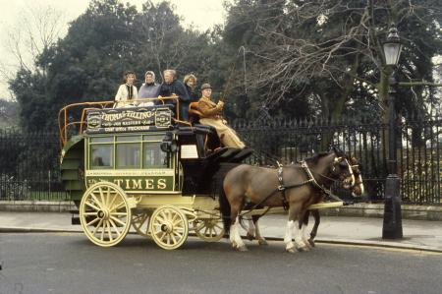  What do you notice? (1875)  What about this one? What’s the same and what’s different? (1911) 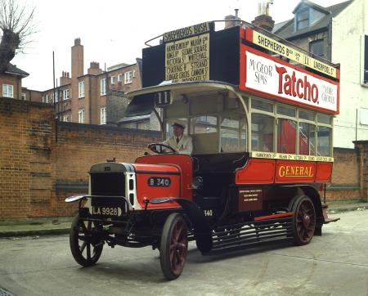  Now have a look at pictures of modern day buses.  Year 1: Tell me how buses have changed from the first picture I showed you to how buses look now.  You could use our ‘door’ words we used when we were in school, like: first, then, next, after that.  Reception: Can you create a bus using Lego or playdough?  Then have a think about what buses might look like in the future, draw a picture of your futuristic looking bus!

