Tuesday 2nd June 2020
Reception
Phonics  English | Reception  What can you remember? Revising Phase 2 & 3 phonemes.  -See which phonemes you can remember in the Speed Trials activity: (Click phase 2&3) https://new.phonicsplay.co.uk/resources/phase/3/flashcards-speed-trials (If you could let me know which phonemes your child is wobbly on, I will plan in some lessons next week to go over those phonemes)  English  Take a look at this page in the story. (Have a go at these questions before watching the video of the story)  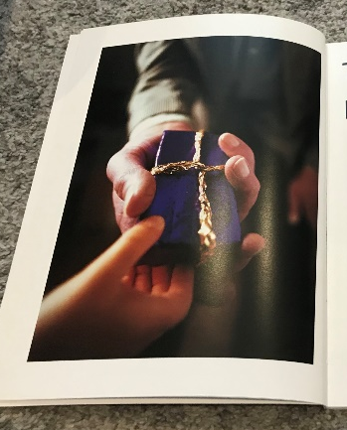  What type of person is giving the gift? (Generous, older, kind etc.)  How do you think the person who is receiving the gift feels?  What might be in the gift?  -Watch today’s entry of Miss Gannon reading the story!  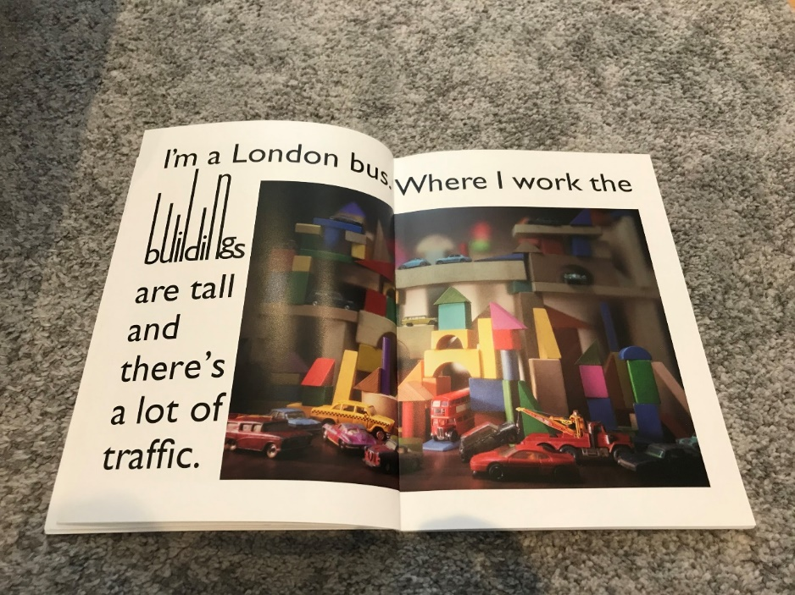  Reception: Can you build your own city of London using building bricks or Lego? If you have a toy bus (or vehicle), have a go at driving it around the city you have built! 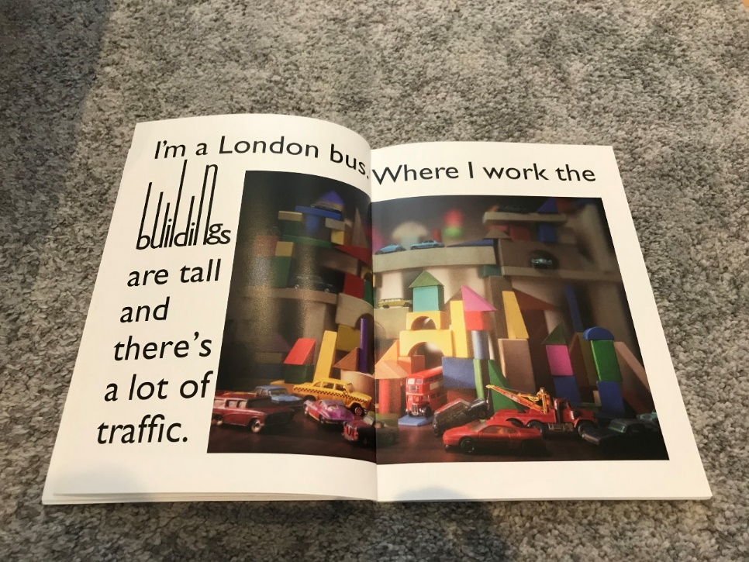
Maths | Halving  Share the Squash!  (Adults: This activity would work really well with lots of different sized measurements of liquid, so if you have a selection of different sized containers please fill them with squash or coloured water).  The aim of the game is to share the squash equally between 2 people (using clear cups for each person is a good idea). The children will need to practise their pouring skills (sorry for any mess!) and make sure each person gets an equal amount.  Once your child is getting the hang of halving, use a handful of counters/cereal/pom poms/sweets to practise halving in a mat like this one: 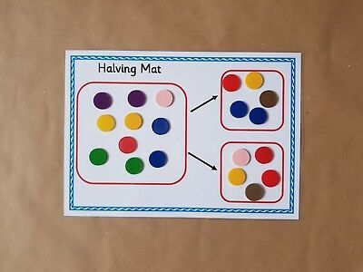  I’d love to see some photos of you halving quantities! You could even write down what half of each quantity was/is!
Topic | Cars & Buses  Look at the PowerPoint Showing pictures of cars from different years.  If your parents drive, ask them if they have photos of their first cars and see how cars might have changed since then.  Look at this picture of a bus 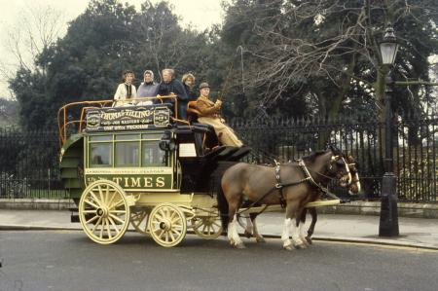  What do you notice? (1875)  What about this one? What’s the same and what’s different? (1911) 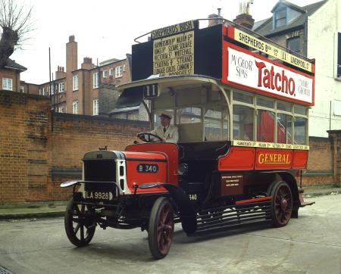  Now have a look at pictures of modern day buses.  Reception: Can you create a bus using Lego or playdough?  Then have a think about what buses might look like in the future, draw a picture of your futuristic looking bus!

