Monday 1st June 2020
Year 1
Spelling Challenge! | Alternative spellings for ‘f’ & tricky words  Phonics, fairy, huff, elephant, rough, phone, roof, friend, school, today
Phonics  English | - Speed Trials! See which Phase 5 phonemes you can remember with this game: (Login is March20 and password is home) https://new.phonicsplay.co.uk/resources/phase/5/flashcards-speed-trials  -Alternative spellings for ‘oa’  -Make a list of 3 words you can think of which have the ‘oa’ phoneme in (examples are toad, load, roast)  -Use this activity to look at the other ‘oa’ spellings: https://new.phonicsplay.co.uk/resources/phase/5/alt-spellings-oa (Use all three activities to explore the different spellings)  -Reading tricky words: water, where, who, again  Our Topic this week is all about different types of transport, so this week in English we are going to be looking at a story about a very Naughty Bus..  Year 1: What makes the word ’naughty’ a tricky word to spell?  This is a picture of the book we will be looking at this week (no peeking at videos of it being read online please!).  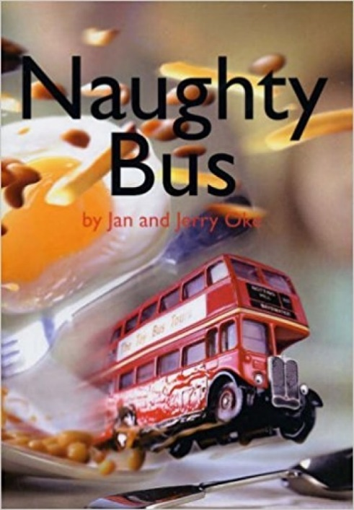  What do you think the story might be about? Use the title and the pictures on the front cover to help with your predictions.  Why do you think the bus might be naughty? What do buses normally do?
Maths | 2D Shapes  Remind yourself of the ways we describe 2D shapes here: https://open.online.clickview.co.uk/libraries/categories/26204561/videos/3711989/describing-2d-shapes  Have a go at the Tangram activity – putting the shapes back together and naming them!  Locating the Logo – Have a go at searching for the hidden shapes in the logos!  Then try the challenge sheet attached to make sure you’re an expert with 2D shapes!
Topic | This week we are going to be looking at how different types of transport have changed over time.  First off, make a list/draw a picture of each type of transport you can think of.  Year 1: Write a list using phonics sounds.  Can you sort the types of transport into different categories (examples could be: amount of wheels, if they have an engine, if they produce smoke/steam).  What type of transport do you think was the first to be ‘invented’?  Discuss walking and then going by horse, horse and cart. Explain that as far back as caveman times, when humans first came to be on this earth (after the dinosaurs), we discovered fire and worked out how to use simple tools and plant things, etc. Thousands of years later we invented the wheel. This has led to transport. When early humans created the wheel, it would have been a stone wheel in the stone age, then wood and metal wheels. We had the wheel for simple carts thousands of years ago.  Wheels  Your challenge: To make your own wheel! Use resources you have available in the house and see how far it rolls!  Bonus points if your wheel has spokes and tread around the outside! 

