Friday 22nd May 2020
Year 1
English | Refresh your brain into plural nouns with this video: https://standalone.espresso.co.uk/espresso/primary_uk_sa/sa_item898714_1/subject/module/video/item910810/grade1/module910304/collection910301/section910915/index.html  Have a go at changing the list of words attached into plurals using -s or -es.  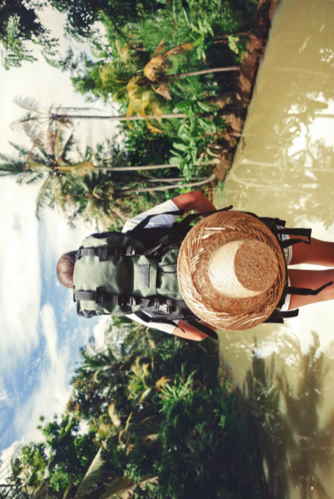  Thinking back to the picture you looked at yesterday have a go at the  Comprehension questions attached.
Maths | Subtraction  Subtraction by crossing 10 game: https://kids.classroomsecrets.co.uk/resource/year-1-subtraction-maths-game-subtraction-crossing-10-1/  Using the numbers  16, 8, 10, 6, 3, 5, can you make two subtraction number sentences? (it is possible!)  Continuing our learning about subtraction and crossing 10, have a go at the subtraction challenges attached! Select your level!
Topic | Thankfully your fantastic designs got us to safety. Ms Everett did a fantastic job of driving us to safety and Mrs McGarrell found us some tasty seafood snacks for the duration of our travel too (I merely provided entertainment and first aid).  Now that we are ashore, it would be lovely if you could make a sea jar to remember our adventure under the sea. Have a look at things you have around the house that could be used to represent parts of our adventure. Here are some ideas:  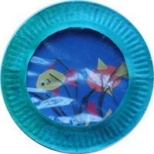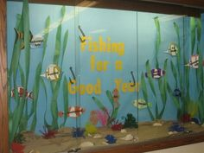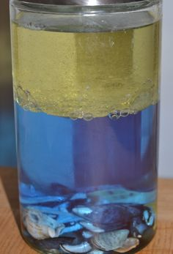  You could even have a go at creating a picture on the computer or even recording your thoughts about the adventure to make a little video!  Science Experiment – Salt Water Density

