Friday 22nd May 2020
Reception
Phonics  English | Reception:  (Adults: write/type these sentences before the lesson)  I got a letter from a farmer.  My ladder was much longer than her ladder.  Get a hammer and bang in a nail.  Ask your child to read the words in the sentences – reminding the children of the ‘er’ sound.    Can you write 5 words of things you can see in the picture using your phonics sounds?  Remember to split the words into their different sounds using your phoneme fingers (like this):  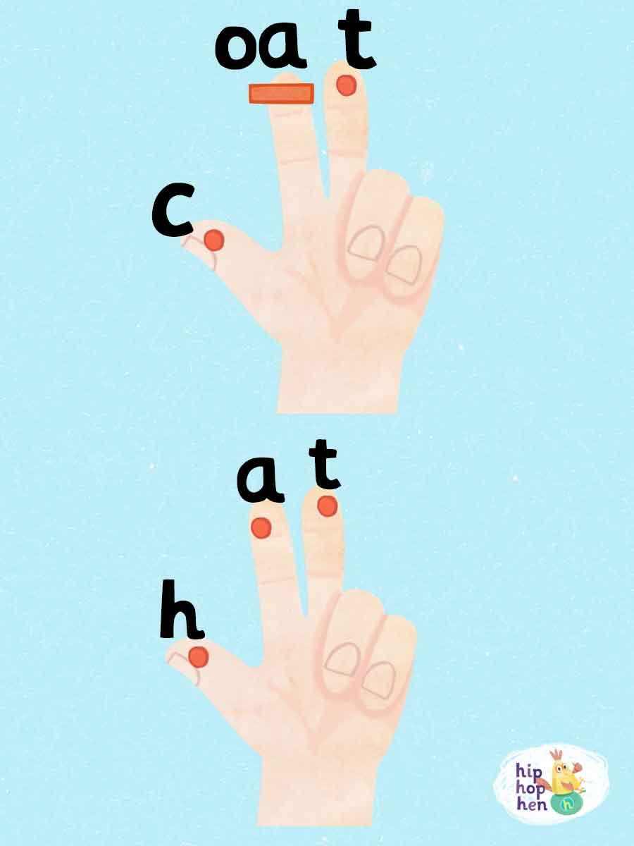
Maths | Length  We can measure lengths of things in different ways, we can use rulers, tape measures, metre sticks, a trundle wheel and with parts of our bodies!  Can you find an object in your house that is taller than you? What about an object which is shorter than you?  Using some playdough, can you make your own set of different length snakes?  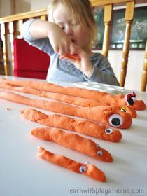  For an extra challenge you could even find out how long each of your snakes are!  Have a look at the other length challenges you could be having a go at which are attached below!
Topic | Thankfully your fantastic designs got us to safety. Ms Everett did a fantastic job of driving us to safety and Mrs McGarrell found us some tasty seafood snacks for the duration of our travel too (I merely provided entertainment and first aid).  Now that we are ashore, it would be lovely if you could make a sea jar to remember our adventure under the sea. Have a look at things you have around the house that could be used to represent parts of our adventure. Here are some ideas:  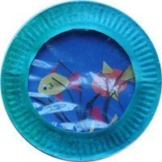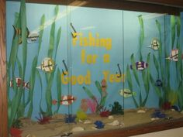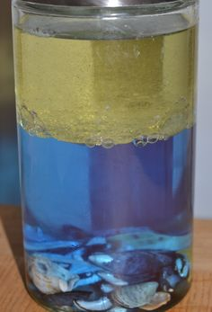  You could even have a go at creating a picture on the computer or even recording your thoughts about the adventure to make a little video!  Science Experiment – Salt Water Density

