Tuesday 19th May 2020
Year 1
Phonics  English | Alternative spellings for ’f’  Mini spelling test: some, come, who, were (all trickywords)  Can you remember any other phonemes which can make the ‘f’ sound?  Can you write these words: fix, cliff, phone, cough  Can you use sound buttons (. and _ under specific sounds) to show the parts of the words which make the ‘f’ sound? 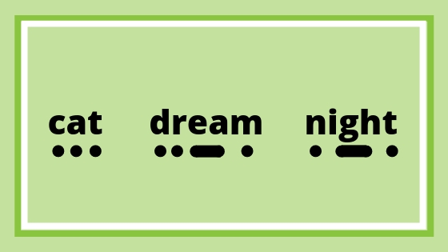  Sorting sounds activity sheet – select your level (easy or challenge/hard)  What is Christian Aid?    Show the Christian Aid logo and show the following facts:  - Christian Aid started after the Second World War, in 1945.  • Christian Aid works in around 50 of the poorest countries all over the world.  • Christian Aid helps in emergencies around the world like earthquakes and floods, but also works all year round to fight poverty.  • Christian Aid’s aim is to end poverty altogether.  • Christian Aid works with people of all religious backgrounds and none.  Task: Christian Aid works in four big areas of the world: Latin America, Africa, the Middle East and Asia. Can you find each of these places on a map?  Learn about Florence’s story here: https://www.youtube.com/watch?v=6Srx7RQm6cw (subtitled)  Learn about Kadiatu’s story here: https://www.youtube.com/watch?v=_tMJ09HMg94 (not subtitled).  Have a go at a few of the activities on the attachment, or alternatively have a go at making your own wordsearch using some keywords you heard from the videos.
Maths | Addition and Subtraction  Today’s Focus: Number Bonds  Adults: In order for children to quickly solve maths questions, number bonds need to be learnt off by heart! The children should all be confident with number bonds to 10, so 6 + 4 = 10 and 9 + 1 = 10 etc) so they will be able to use these facts to add numbers to 20.  Star Jumps Number Bonds:  Hide the numbers 1 to 10 with two number 5s around the house (1,2,3,4,5,5,6,7,8,9,10).  The children need to find the two number pairs which make ten, when they bring them back to you they must do 10 star jumps to represent the total. Continue until all their pairs are found!  Tens frames:  are really useful if your child is a little wobbly (we use them regularly at school), use two different colours to represent the two numbers to show that the whole tens frame is full once the two numbers are inside: 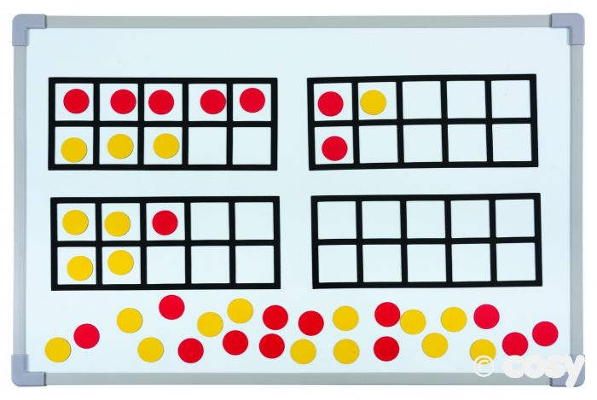 (This is an example although these tens frames don’t show number bonds to 10- I did look but couldn’t find a number bond example with two colours, sorry!)  Have a go at the Number Bond cards attached to see if you’ve nailed number bonds!
Topic | Oh no! We are still stuck under the sea! Unfortunately, our submarine wasn’t able to come and take us ashore because of a leak!  That means that we will need to find a place to stay and find something to eat!  Can you design a house for us to live in and a meal for us to eat? Remember our meal will need to be things we can locate under the sea! Luckily, we still have our scuba diving gear on!  Another science experiment: Have a go at the Frozen Sea science experiment!

