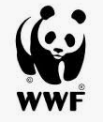 |  | 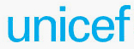
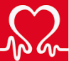 |  | 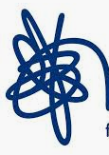
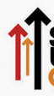 |  | 

 |  | 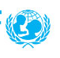
World Wildlife Fund | Oxfam | UNICEF
British Heart Foundation | Cancer Research UK | Mind
Stand up 2 Cancer | Barnado’s | Break

