Thursday 14th May 2020
Year1
English | Today we are going to start writing your story/diary! We are going to start with the first 4 boxes in your story plan.  (I’ve written about the first 4 boxes in my plan to give you an idea of how it might sound.)  Remember to use capital letters and full stops.  Top tip: adjectives (describing words) can make your writing sound even better!
Maths | Time  Watch this video to remind you of the vocabulary we use when talking about time: https://numberock.com/lessons/units-of-time/  (There’s another video here if needed: https://open.online.clickview.co.uk/libraries/categories/26204561/videos/9904741/units-of-time)  There are different units of measurement when it comes to time, they begin with a m_______, h____ and s_____. Can you remember what they are? (minute, hour, second)  In today’s activities, you need to decide on the type of measurement for an activity given (see attached, same as yesterday select your level or do all 3 if you are up for a challenge!)
Topic/R.E | Judaism  There are 6 main religions in the world, do you know the names of them all? (Christianity, Islam, Judaism, Buddhism, Hinduism and Sikhism).  Judaism is one of the oldest religions of the world. The followers of Judaism are referred to as Jews.  Today we will be looking at the symbol of Judaism, where Jews worship and their holy book.  This is the symbol of Judaism: 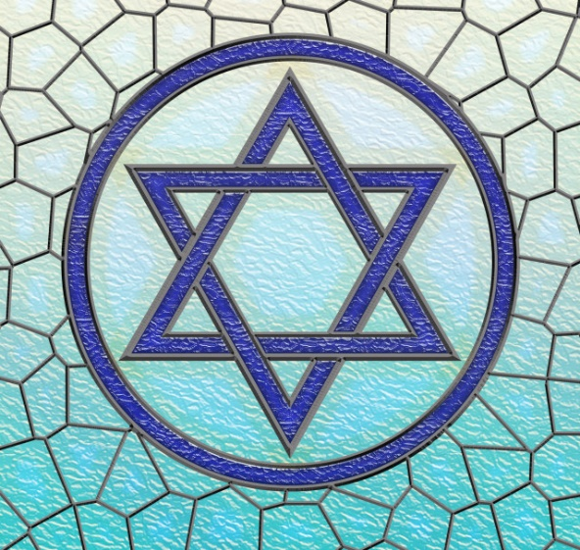  What shapes can you see in the Star of David (the name of the symbol)-look closely!  Can you make your own Star of David with lolly sticks?  Learn about the Synagogue here: https://www.youtube.com/watch?v=gBVhIBgdNaM  This is the Torah, the name of the Judaism Holy Book.  

