Thursday14th May 2020
Reception
Phonics  English | Sentence Substitution  Some words in sentences can easily be swapped to other words to change the meaning of the sentence. Have a go at the Sentence Substitution game here to practise reading words and swapping between them. https://www.phonicsplay.co.uk/member-only/SentSubPhase3.html  Login: March20 Password: home  If the link doesn’t work, you could write the words individually, here are two examples.  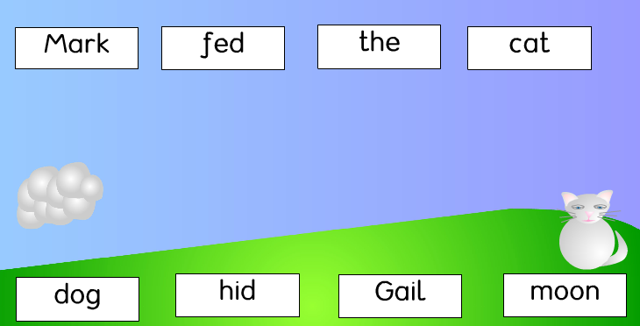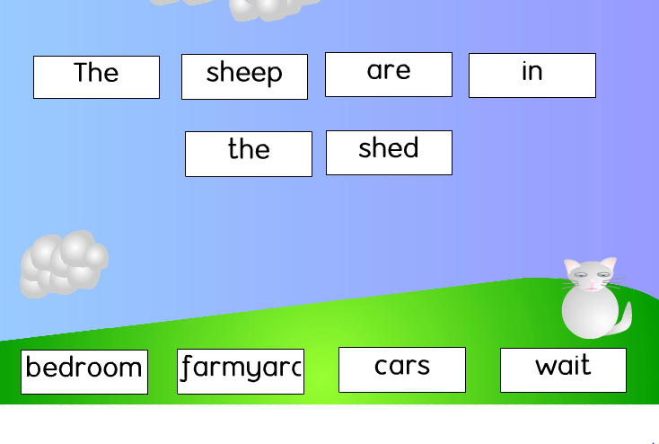  Have a go at performing your story/event with some toys you have at home, if your event takes place in a castle, you could find a picture of a castle and pretend your characters are there! (Adults, it would be great if you could record your child ‘performing’ and upload this to Tapestry!)  Take a look at your ‘story’ that you drew in yesterday’s lesson, have a go at performing your story/event with some toys you have at home! If your event takes place in a castle, you could find a picture of a castle and pretend your characters are there! (Adults, it would be great if you could record your child ‘performing’ and upload this to Tapestry!)
Maths | Counting from 0 – 20  Have a go at this matching activity by counting each of the cubes to find the total number.  https://kids.classroomsecrets.co.uk/resource/reception-matching-numbers-to-amounts-game-0-20/  Super challenges: Count from 0 – 20 whilst doing star jumps!  Write the numbers from 0-20 on separate pieces of paper. Mix them all up and have a go at re-ordering them from smallest to largest.  Have a go at these number problems, (a handful or cereal, counters or other individual objects would be useful for this).  Mr J has 14 cats. 1 runs away, how many does he have left?  Katie has 10 mugs. She puts 5 in the dishwasher. How many are not in the dishwasher?  Billy has 19 ice cubes, 9 melt. How many haven’t melted?
Topic/R.E | 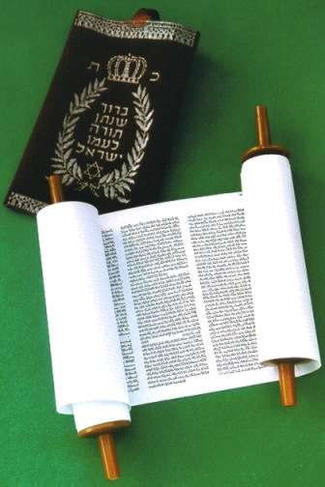  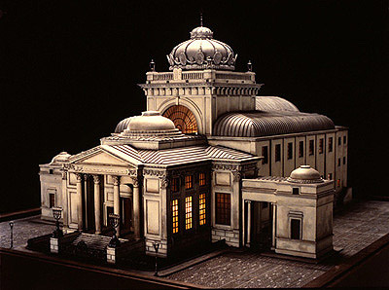  Judaism  There are 6 main religions in the world, do you know the names of them all? (Christianity, Islam, Judaism, Buddhism, Hinduism and Sikhism)  Judaism is one of the oldest religions of the world. The followers of Judaism are referred to as Jews.  Today we will be looking at the symbol of Judaism, where Jews worship and their holy book.  This is the symbol of Judaism: 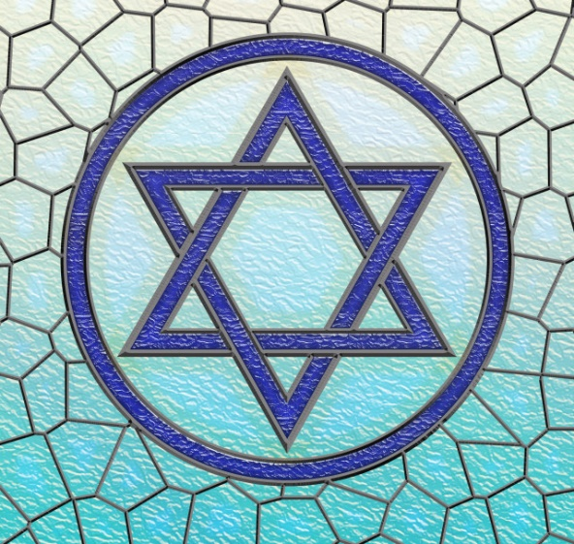  What shapes can you see in the Star of David (the name of the symbol).  Task: Can you make your own Star of David with lolly sticks?  Learn about the Synagogue here: https://www.youtube.com/watch?v=gBVhIBgdNaM  This is the Torah, the name of the Judaism Holy Book.  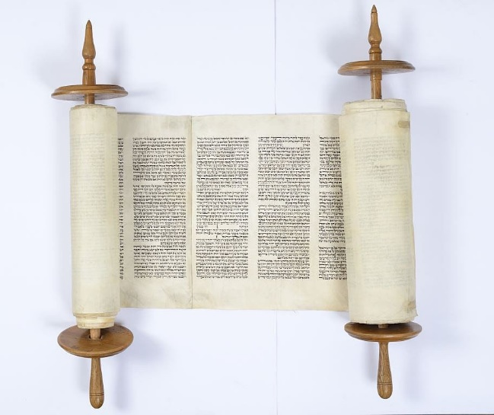  Task: Can you use resources available to you at home to make your own special book?

