13th May 2020
Reception
English: Let’s draw a story
Now that you’ve had a good think about your special event, we are going to plan out our story/diary. Remember that in Gregory Cool he told us about how we got to Tobago, what he saw and how he felt throughout the story.
Can you draw pictures to help retell your event/story (use the grid below to map out each different part of your event) You could even have a go at writing a sentence for each picture too for an extra challenge!

Maths: Days of the Week
Watch this very catchy video reminding us of the days of the week- can you join in with the words?
https://www.youtube.com/watch?v=3tx0rvuXIRg
Have a go at making a days of the week spinner like this one to help you spot the days before and after each day.
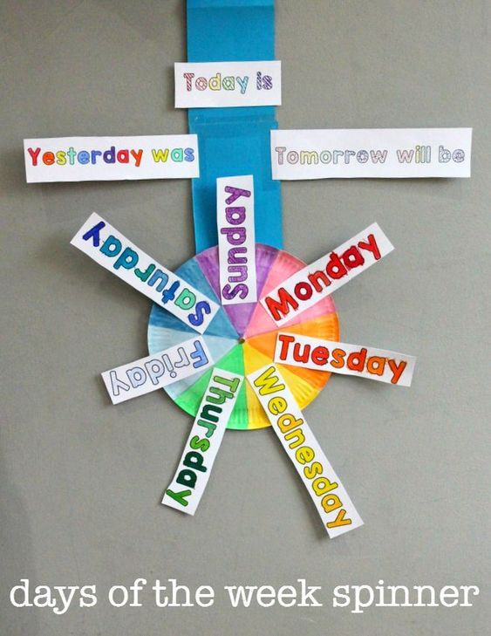
Hide and Seek!
Write out each of the days of the week and ask an adult to hide them around the house! Can you find all seven and put them in the right order?

Topic: What is a compass?
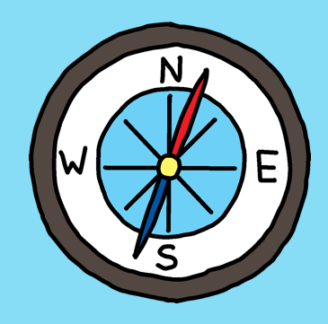

Compasses are really useful to find the direction we are facing. People use compasses to help find the direction of the sun in the sky and when they are out walking – especially when doing some ‘orienteering’.

An easy way to remember the different points on a compass is: Never Eat Shredded Wheat or Naughty Elephants Spray Water!

Ask your parents if they have a compass app on their phone and use the compass to give directions to people like: ‘take two steps north’.

There is an instruction activity sheet attached for you to follow the instructions to reach a destination!

