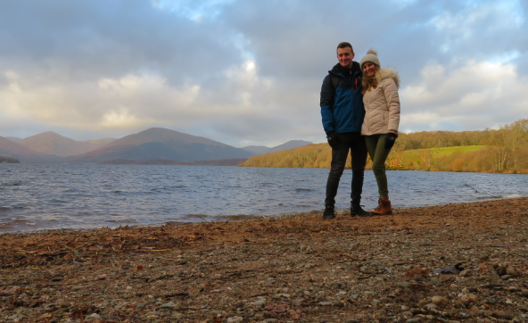
This picture was taken in January 2020. I took Ryan (my partner) away for his birthday to Edinburgh in Scotland!
I remember this day because we went on a lovely walk around a huge lake called Loch Lomond. It was really cold but we had this glorious view behind us which made us both feel really happy. We made sure we had lots of layers on and our walking gear so that we were warm enough in the 5 degree ‘heat’!

