Year 1 Comprehension questions:
Top tip: Can you use because in your answers to explain them?
Why do you think the little girl is so happy at the beginning of the video?

What colour are the flowers the little girl is surrounded by? Tick one
Green
Blue
Red

What type of animal does she meet?

Why do you think the animal ran away from the girl?
_________________________________________________________________________________
_________________________________________________________________________________
Happy
Nervous
Scared
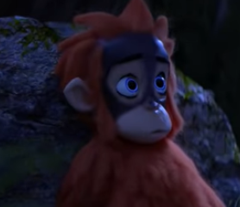
How do you think he feels? Tick two

Why do you think he feels like this?
_________________________________________________________________________________
_________________________________________________________________________________


What does this picture show us?

_________________________________________________________________________________
_________________________________________________________________________________
How did this video make you feel? Did your feelings change throughout the video?
_________________________________________________________________________________
_________________________________________________________________________________
_________________________________________________________________________________
_________________________________________________________________________________

