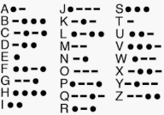
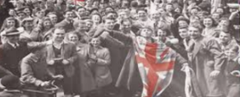
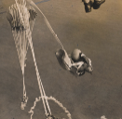

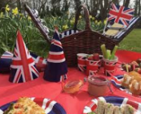

Here are some home learning tasks to celebrate the 75th anniversary of VE Day – marking 75 years since the end of WW2. These activities are for you to enjoy as a family leading up to the celebrations being held on Friday 8thMay, which is a Bank Holiday. Please upload your photos and any work so we can share and enjoy the celebrations together.
Morse Code was used during the war as a way of sending messages.
Can you write your name in Morse Code?
(see Morse Code Poster)

Challenge: can you write a secret message for somebody in your family to crack in Morse Cose? You could even send it to your teacher!
Many countries were a part of World War II.
Can you choose a country and draw their flag, writing the country’s name underneath?

VE Day tea party
Set up your own ‘tea party’ with your toys to celebrate the 75th anniversary of VE Day.
Challenge: Can you make a menu for your tea party?


No party is a party without some decorations and this was the case when people held their celebrations at home.
Design and create your own party decorations. They may include: bunting, flags, posters etc.

During the war parachutes were used by paratroopers, some were even accompanied by dogs.
Design and make your own parachute using materials from around the house. Time how long it takes for your parachute to fall to the floor. You could hold it yourself or even ask an adult to help you drop it from a window.
Challenge: Can you write a sentence to say which parachute fell the fastest and why you think so?
Can you find all the words in the VE day word search? (see VE Day word search). You can write the words in your book.
Challenge: Draw an image/write a definition of some of the words.

Medals were given by the British Government to those who participated in World War II.
Design your own medal for a British Soldier to acknowledge their role in the war.
Think about the shape of the medal and colour of the ribbon.

Every year people celebrate VE Day. Can you draw a picture and display it in your window to show that you are joining in the celebrations?
Challenge: Can you add speech bubbles to explain how people are feeling and what they might say?
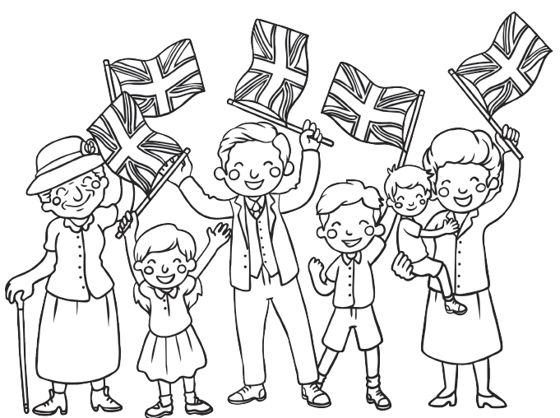
On VE day street parties took place all over the country to celebrate.
Design a picnic with all of your favourite foods to have at your very own VE Day party.

Home Learning -VE Day Celebrations.

