Wednesday 6th May 2020
Year 1
Poetry
Look at this picture and create as many pairs of rhyming words as you can!
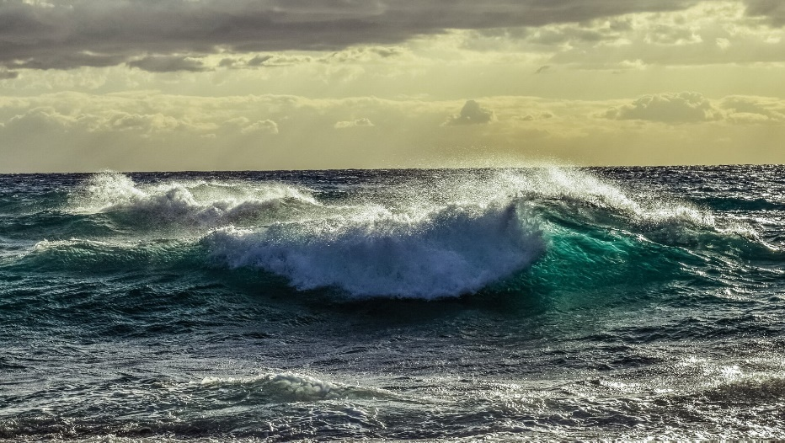
E.g: Sea and tea
Blue and you.
Clean and mean.
After you’ve created your rhyming couplets, can you write a rhyming poem about the picture? What are you going to call your poem?
Remember to try and keep each length of your poem a similar size!
Maths: Number and Place Value
We were fantastic at this when we did some work on this when we were at school so I’m sure you’re going to smash this today!
We are going to be comparing numbers using greater than and less than (do you remember those funny little arrows > < which some people think look like crocodile mouths!)!
As a little starter to this lesson, see if you can find a pack of playing cards at home, split the cards into two piles and play a game of ‘snap’ although in this game, rather than looking for the same card, you are going to spot which card has a higher value! If you spot it first, you get to keep the cards! The player with the most cards at the end wins! Good luck!

This video shows how to compare numbers easily: https://www.youtube.com/watch?v=fd-Uw-uRGFE

Have a go at the activity attached to compare the numbers. Comparing Numbers (2)

Human and Physical Features in Castle Acre

Some things we see around us in our environment have been produced by nature and some have been man made (not naturally formed). This afternoon we will learn about these different features.
Take a look at the PowerPoint attached to look at some naturally formed features and manmade features.
After you’ve sussed what the difference is between human and physical features, on your daily walk, use the observation sheet to spot human and physical features in Castle Acre (or where you live).
Extra challenge: Write a report about the Human and Physical features you spotted! You could talk about which direction you walked to find them!

