Year 3 Challenge

Task 1

Synonyms for said

Think of at least 8 other speech verbs that you can use instead of said and write them down in your book.

Look at the comic strip speech bubbles below. Change each speech bubble into a speech sentence with inverted commas. The first has been done for you. Use a different speech verb each time
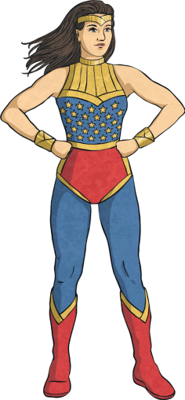


Hold on tight! I’ll save you!
The superhero flew through the air and shouted, “Hold on tight! I’ll save you!” The superhero flew through the air and shouted, “Hold on tight! I’ll save you!”


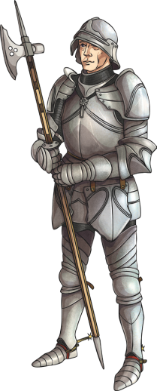

Hold on tight! I’ll save you. I will protect the castle from the dragon.

_____________________________________________________________________________________________________________________________________________________________________________________________________________________________________________________


I wonder how I solve this?
problem.

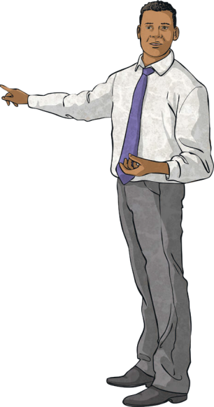

Take out your books and write the date please.
______________________________________________________________________________________________________________________________________________________________________________________________________________________________________________________

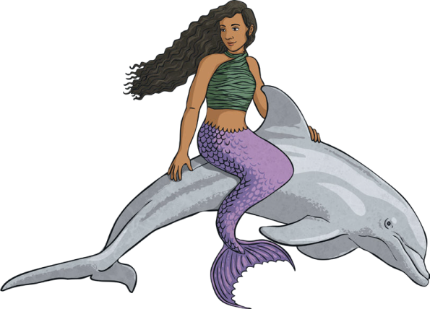

I wonder what treasures I’ll find in the sunken ship?

__________________________________________________________________________________________________________________________________________________________________________________________________________________________

