Monday 4th May 2020
Year 1
English: Question Marks
Watch this video to remind you what Question Marks are: https://www.bbc.co.uk/bitesize/topics/z8x6cj6/articles/zcm3qhv
Have a go at the activities at the bottom of the webpage (after watching the video, scroll down).

Can you match the questions and answers together in this activity? How do you know they are a pair? (Attached)

Then have ago at writing 5 questions which could give this answer:
‘We missed the plane’
e.g: Why didn’t I see you on holiday?

Top tip: Think of questions which start with one of these words:

Maths:
Counting to 100
Using a dice you have at home, roll it twice and create 2 numbers by swapping the numbers over e.g. 16 and 61.
Continue this until you have 10 numbers altogether.
Can you order all 10 numbers from smallest to largest? How did you know how to order them?

Activity 2. Take a handful of 30 beads/pasta shells/counters you have around the house. Close your eyes and ask an adult to take a small handful of the counters and drop them in front of you (away from the other pile of counters). Have a go at recognising the total of counters in front of you in as quick amount of time as possible. (Parents: this activity will help your child’s counting and fluency skills). As an extra challenge: how many counters are in the other pile now that you know how many counters are in front of you. Could you draw a bar model to show the two parts making 30?
(A picture of what it might look like).
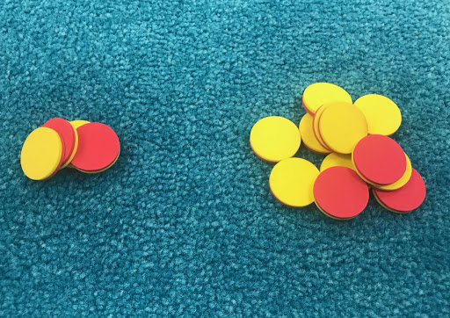

Have a go at the activity sheet at the bottom of the page.

Topic:
What is the United Kingdom?
The United Kingdom is the name for the part of the world we live in, we live in a part of the United Kingdom. Do you know the name of the part we live in?... England!
There are 3 other parts of the United Kingdom though, can you find out their names and their capital cities and label the map attached?
An extra challenge: The United Kingdom is found in the continent of Europe, can you find the other countries in Europe to label these too?

