 |  | ______ p
 |  | ______ p
______ p | 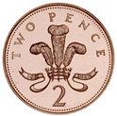
______ p |   

Use >, < or = to compare the money.



Count the money.
p
p
Jamie selects four of these coins.


He can use the coins more than once.

What total could he make? ___p + ___p + ___p + ___p = ___p

What is the lowest total? ___p + ___p + ___p + ___p = ___p

What is the greatest total?
___p + ___p + ___p + ___p = ___p

