Monday 27th April Science
What is friction? Watch the video clip
https://www.bbc.co.uk/bitesize/topics/zsxxsbk/articles/zxqrdxs
Write a definition in your book. Friction is………………………..
Investigating friction
Different surfaces create different amounts of friction.
The amount of friction created by an object moving over a surface depends on the roughness of the surface and the object, and the force between them.

This week at home can you carry out your own friction experiment.
You will need something that will roll: toy car, marble, ball
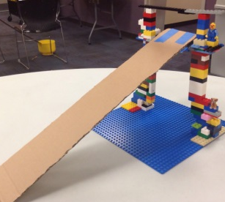
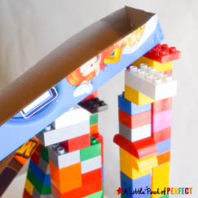
A ramp made from wood ,cardboard or any other suitable materials ( you will need to be able to move it).
Measuring tape/ruler
Method
- Create your ramp.
- Predict which surface will create the most friction.
- Roll the car or object you have from the top of the ramp on to different surfaces such as grass, carpet, concrete, gravel, tiles.
- Measure and record how far the car or objects travels along the different surfaces.
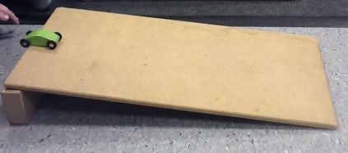
What did you find out?
How did you make the test fair?
Could you have carried out this experiment to investigate friction on different surfaces ( Hint : could you do something to the ramp each time?)
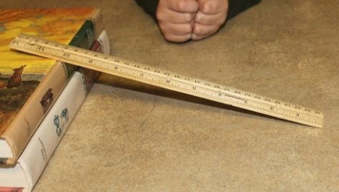
Take some pictures of you carrying out your investigation or even a little video if you can and post it on your portfolio!

