Monday 20th April
Features of Instructions
- Chronological Order
- Materials needed
- Imperative Verbs
- Title
- Picture/Diagram
- Time Connectives
- Introduction
- Final sentence
- Top Tip
How to make a Catapult
Look carefully at the pictures before you start
Task: To write a set of instructions to go with the pictures below in your
book. Remember the important features when writing instructions that you need to include.
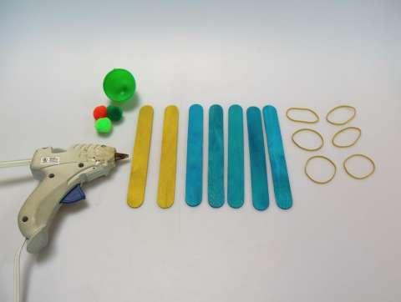
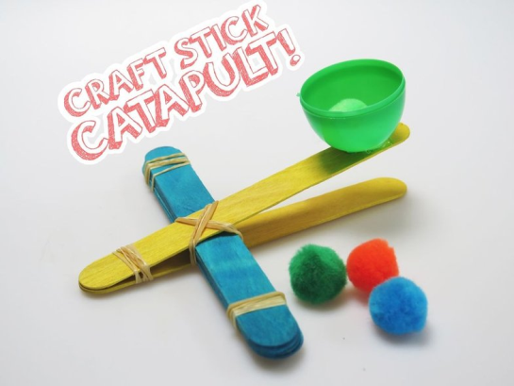

What you need:

- Glue Gun
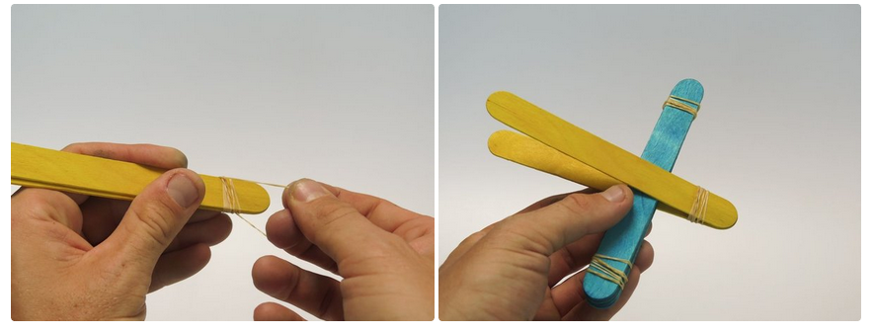
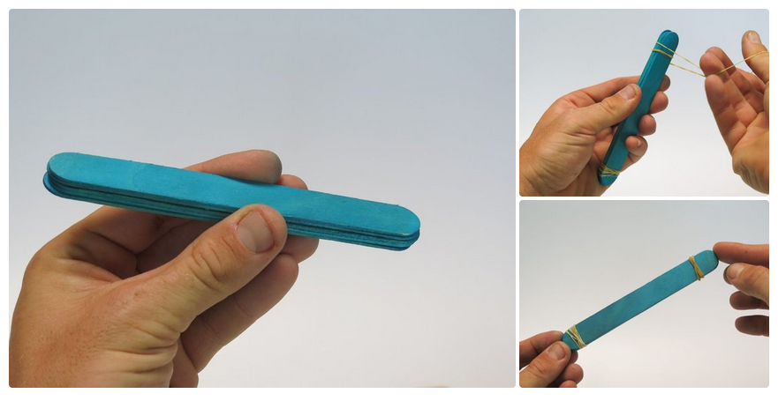
1
2

- Take………………………….
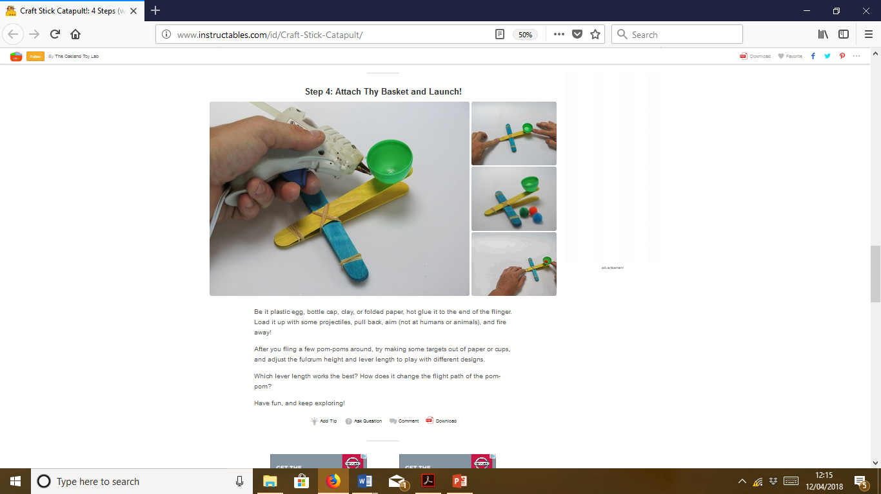
- Wrap ………………………………
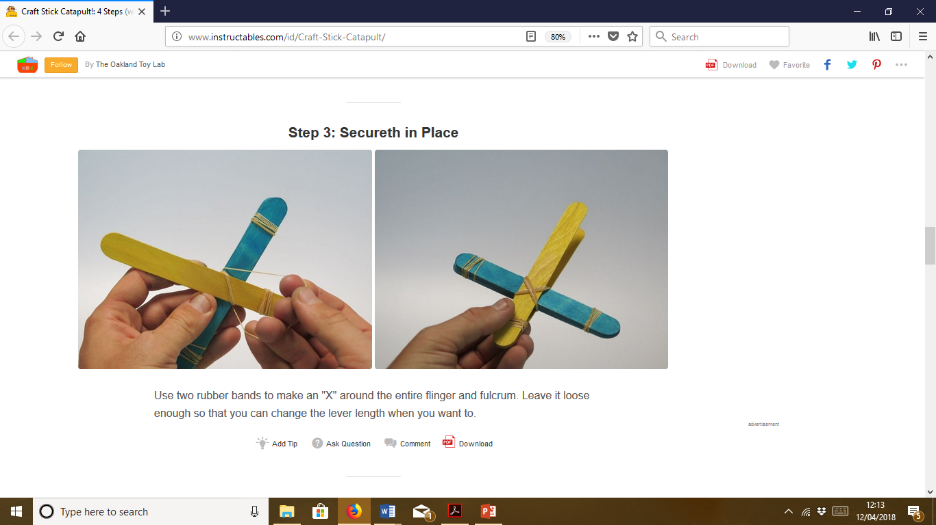
4
3

Finally………………………………………
Top tip

