Monday 20th April
Features of Instructions
- Chronological Order
- Materials needed
- Bossy/Imperative Verbs
- Title
- Picture/Diagram
- Time Connectives
- Introduction
- Final sentence
- Top tip
How to make a Catapult
Look carefully at the pictures before you start
Task: To write a set of instructions to go with the pictures below in your
book. Remember the important features when writing instructions that you need to include.
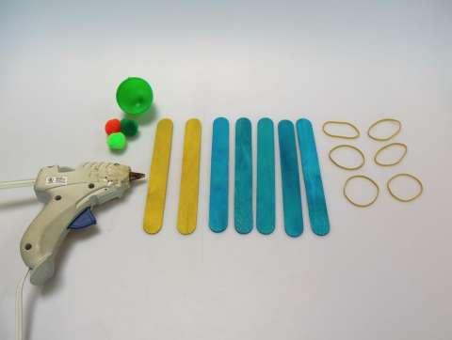
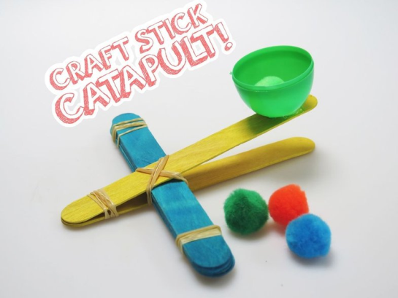

What you need:
- Glue gun
- 6………………
- 7………………………
- Bottle top
- …………………………….
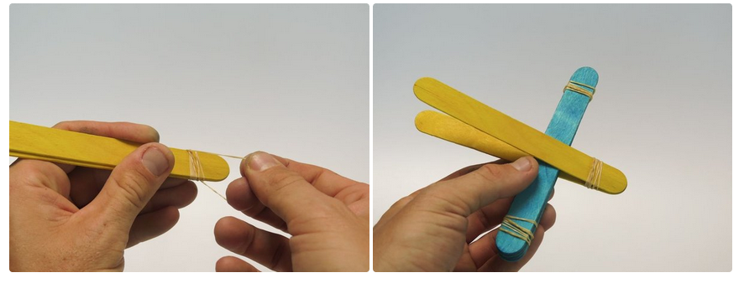
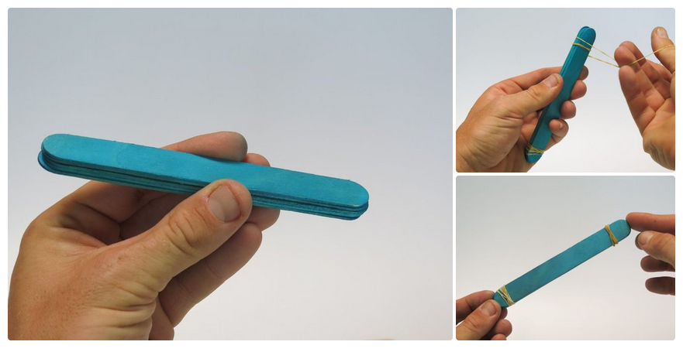
2
1

1.Take ….. 3.Next…………………………………………….
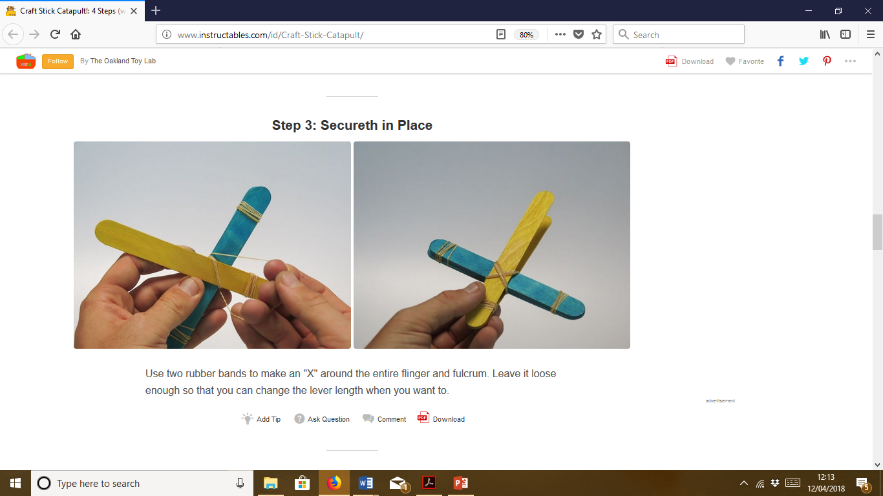
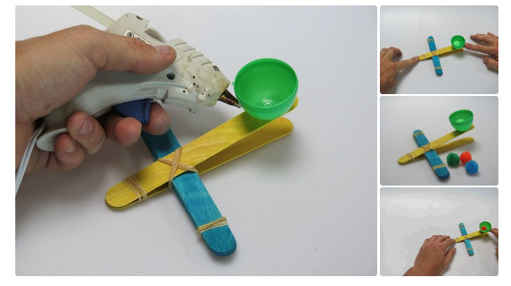
2.Wrap……………………… 4.Wedge……………………………………….

4
3

5. Wrap an ……………………………………… 6.Glue …………………………
7.Finally …………………………. Top Tip

